Enhanced Underwater Fish Detection: A Comparative Study of YOLOv9 and Faster R-CNN

A Project Report submitted
in partial fulfillment of the requirements
for the award of the degree of

BACHELOR OF TECHNOLOGY

In

COMPUTER SCIENCE & ENGINEERING

By

1. KONAGALLA TEJASWI - 21B01A0583
2. PALEPU HARIKA SAHITHI - 21B01A05D0
3. MARUBOYINA JHOTHSNA NAGA PADMINI - 21B01A05A0
4. KOTIPALLI AAMANI NAGESWARI - 22B05A0508
5. NUNNA PHANI SANJANA - 21B01A05C3

Under the esteemed guidance of
Mr.Ch. Phaneendra Varma _{M. Tech, (Ph.D.)}
Assistant Professor



DEPARTMENT OF COMPUTER SCIENCE & ENGINEERING
SHRI VISHNU ENGINEERING COLLEGE FOR WOMEN(A)
(Approved by AICTE, Accredited by NBA & NAAC, Affiliated to JNTU Kakinada)
BHIMAVARAM – 534 202
2024 – 2025

SHRI VISHNU ENGINEERING COLLEGE FOR WOMEN(A)
(Approved by AICTE, Accredited by NBA & NAAC, Affiliated to JNTU Kakinada)
BHIMAVARAM – 534 202

DEPARTMENT OF COMPUTER SCIENCE & ENGINEERING



CERTIFICATE

This is to certify that the project entitled “Enhanced Underwater Fish Detection: A Comparative Study of YOLOv9 and Faster R-CNN”, is being submitted by Konagalla Tejaswi, Palepu Harika Sahithi, Maruboyina Jhothsna Naga Padmini, Kotipalli Aamani Nageswari, Nunna Phani Sanjana bearing the Regd.No’s. 21B01A0583, 21B01A05D0,21B01A05A0,22B05A0508,21B01A05C3 in partial fulfillment of the requirements for the award of the degree of “Bachelor of Technology in Computer Science & Engineering” is a record of Bonafide work carried out by her under my guidance and supervision during the academic year 2024–2025 and it has been found worthy of acceptance according to the requirements of the university.

Internal Guide Head of the Department

External Examiner

ACKNOWLEDGEMENT

The satisfaction and euphoria that accompany the successful completion of any task would be incomplete without acknowledging the people who made it possible, whose constant guidance and encouragement crowned our efforts with success.

We wish to place our deep sense of gratitude to Sri. K. V. Vishnu Raju, Chairman of Sri Vishnu Educational Society, for creating excellent academic infrastructure to support this project.

We take this opportunity to express our profound gratitude to Dr. G. Srinivasa Rao, Principal of SVECW, Dr. P. Srinivasa Raju, Director and Admin of SVES, Mr. P. Venkata Rama Raju, Vice-principal of SVECW for their constant support and encouragement.

We wish to express our deep sense of gratitude to Dr. P. Kiran Sree, Head of the Department of Computer Science and Engineering, for his valuable advice in completing this project successfully.

We are deeply thankful to our project coordinator, Dr. P. R. Sudha Rani, Professor, Department of Computer Science and Engineering, for her indispensable guidance and unwavering support throughout our project completion. Her expertise and dedication have been invaluable to our success.

We wish to express our sincere thanks to our PRC members Dr. A. Seenu, Mr. Y. Ramu, and Dr. T. Gayathri, for their invaluable advices in successfully completing this project.

We sincerely thank our guide, Mr. Ch. Phaneendra Varma, Assistant Professor, Department of Computer Science and Engineering, for providing his valuable suggestions and guidance throughout our project.
Project Associates:
- K. Tejaswi - 21B01A0583
- P. Harika Sahithi - 21B01A05D0
- M. Jhothsna Naga Padmini - 21B01A05A0
- K. Aamani Nageswari - 22B05A0508
- N. Phani Sanjana - 21B01A05C3

ABSTRACT
This study presents an innovative approach to fish target detection by leveraging the advanced capabilities of YOLOv9 and Faster R-CNN, two of the leading convolutional neural network models designed for real-time object detection. With the aim of enhancing the accuracy and efficiency of underwater fish detection in diverse and complex aquatic environments, this research compares the performance of YOLOv9 and Faster R-CNN in terms of detection speed, accuracy, and reliability. Utilizing a comprehensive dataset of underwater images featuring various fish species in different settings, the study meticulously evaluates each model's ability to accurately identify and locate fish targets amidst background noise and varying visibility conditions. The findings demonstrate that YOLOv9, known for its speed and lightweight architecture, excels in scenarios requiring real-time detection, while Faster R-CNN, with its emphasis on detection accuracy through region proposal mechanisms, shows superior precision in complex image contexts. This comparative analysis not only sheds light on the strengths and weaknesses of each model in fish detection tasks but also provides valuable insights for the development of more effective and adaptive aquatic life monitoring systems. Through this exploration, the research contributes to the advancement of marine biology studies, sustainable fishing practices, and the preservation of aquatic ecosystems by offering a robust tool for accurate and efficient fish detection.

CONTENTS

S. No Topic Page No
- Introduction 1 - 5
- System Analysis 6 - 12
  - Existing System
  - Proposed System
  - Feasibility Study
  - Project Flow
  - Architecture
- System Requirements Specification 13 - 15
  - Software Requirements
  - Hardware Requirements
  - Functional Requirements
  - Non-functional Requirements
- System Design 16 - 27
  - Introduction
  - UML Diagrams and Data flow diagrams
  - Database Design
    - ER Diagrams
    - Table Structures
- System Implementation 28 - 43
  - Introduction
  - Project Modules
  - Algorithms
  - Screens
- System Testing 44 - 57
  - Introduction
  - Testing Methods
  - Test Cases
  - Results
- Conclusion 58 - 59
- Future Scope 60 - 61
- Bibliography 62 - 64

- Appendix 65 - 82
  - Appendix-A
  - Introduction to Python Programming
  - Front End
  - Back End
  - Introduction to Deep Learning

LIST OF FIGURES
Fig. No Figure Name Page No
2.4 Project Flow 11
2.5 Architecture 12
4.2.1 Use Case Diagram 19
4.2.2 Class Diagram 20
4.2.3 Sequence Diagram 21
4.2.4 Collaboration Diagram 22
4.2.5 Deployment Diagram 22
4.2.6 Component Diagram 23
4.2.7 Activity Diagram 23
4.2.8.1 Context Diagram 24
4.2.8.2 DFD Level-I Diagram 25
4.2.8.3 DFD Level-II Diagram 25
4.3.1 ER Diagram 26
5.1 Flow of proposed system 31
5.4.1 Landing Page 37
5.4.2 About Page 38
5.4.3 Registration Page 38
5.4.4 Login Page 39
5.4.5 Home Page 39
5.4.6 Upload Page 40
5.4.7.1 Detection Result Page (Puffin, Fish) 40
5.4.7.2 Detection Result Page (Penguin) 41
5.4.7.3 Detection Result Page (Overlapped Fishes) 41
5.4.7.4 Detection Result Page (Jellyfish) 42
5.4.7.5 Detection Result Page (Starfish, Fish) 42
5.4.7.6 Detection Result Page (Low visibility conditions) 43
5.4.7.7 Detection Result Page (Shark, Fish) 43
6.3.1 Registration Page with alert-1 50
6.3.2 Registration Page with alert-2 50
6.3.3 Registration Page with alert-3 51
6.3.4 Registration Page with alert-4 51
6.3.5 Login Page with alert-1 51
6.3.6 Login Page with alert-2 52
6.4.1 Confusion matrix for YOLOv9 predictions 55
    - Graphs regarding YOLOv9 predictions 55
10.4.1 XaMPP Server Control Panel 72
10.5.1 Fully Connected Deep Neural Network 76
10.5.2 CNN architecture 78

1.INTRODUCTION

INTRODUCTION

1.1 OBJECTIVE OF PROJECT:
The primary objective of this project is to develop and refine a highly accurate and efficient system for detecting fish in underwater environments, using advanced object detection models, YOLOv9 and Faster R-CNN. By harnessing the capabilities of these cutting-edge convolutional neural networks, the project aims to address the challenges associated with underwater fish detection, such as varying light conditions, the presence of obstructions, and the need for real-time processing. This endeavour seeks to compare the performance of YOLOv9 and Faster R-CNN in terms of detection speed, accuracy, and reliability under diverse conditions, with the goal of identifying the most suitable model or combination of models for real-world applications. Ultimately, this project intends to contribute to the fields of marine biology, conservation efforts, and sustainable fishing practices by providing a robust tool for monitoring aquatic life, thus enabling better management of marine resources and preservation of aquatic ecosystems.

1.2 PROBLEM STATEMENT:
The monitoring and study of marine life, including fish species in their natural habitats, present significant challenges due to the complex and diverse conditions of aquatic environments. Traditional methods for underwater fish detection often struggle with issues related to background noise, varying visibility, and the dynamic nature of underwater scenes. These limitations hinder the efficiency and accuracy of marine biological studies, sustainable fishing practices, and efforts to preserve aquatic ecosystems. Thus, there is a pressing need for an advanced, robust, and efficient tool that can overcome these challenges by accurately detecting and monitoring fish in real-time across diverse and complex aquatic environments. This study aims to address this gap by leveraging the capabilities of two leading convolutional neural network models, YOLOv9 and Faster R-CNN, renowned for their object detection abilities. By comparing their performance in terms of detection speed, accuracy, and reliability in underwater settings, this research seeks to identify the most effective approach for enhancing fish detection tasks, thereby contributing to the advancement of marine biology, sustainable fishing, and the conservation of aquatic ecosystems.

1.3 MOTIVATION:
1. Enhancing Marine Biodiversity Conservation: The conservation of marine biodiversity is vital for maintaining ecological balance and supporting the livelihoods of millions of people worldwide. Efficient and accurate detection of fish and other marine life plays a crucial role in monitoring the health and diversity of aquatic ecosystems. By improving detection methods, this research directly contributes to the preservation and sustainable management of marine resources.
2. Advancing Marine Biological Research: Marine biologists rely on accurate data regarding species distribution, behaviour, and population dynamics to conduct their research. Traditional observational methods are often labour-intensive, costly, and limited in scope and accuracy. The adoption of advanced detection technologies can revolutionize the way marine biological research is conducted, providing more reliable data at a fraction of the time and cost.
3. Supporting Sustainable Fishing Practices: Overfishing and bycatch are significant concerns that threaten marine ecosystems and the sustainability of fishing industries. By developing more precise fish detection tools, this study aims to aid in the implementation of more sustainable fishing practices, ensuring that fish populations are harvested responsibly and with minimal ecological impact.
4. Leveraging Technological Innovations: The fields of artificial intelligence (AI) and machine learning have seen remarkable advancements in recent years, particularly in object detection algorithms such as YOLOv9 and Faster R-CNN. This study is motivated by the opportunity to apply these cutting-edge technologies to the unique challenges of underwater fish detection, showcasing their potential to address real-world environmental and biological problems.
1.4 SCOPE:
1. Model Evaluation: The primary scope involves a detailed assessment of YOLOv9 and Faster R-CNN models in terms of their detection speed, accuracy, and reliability when applied to underwater fish detection. This includes analysing how well each model performs under different environmental conditions, such as varying visibility, background noise, and the presence of multiple fish species.

2. Dataset Utilization: Utilizing a comprehensive dataset of underwater images featuring various fish species across different settings and conditions. The scope includes the collection, preparation, and augmentation of this dataset to ensure it effectively challenges the models and provides a robust basis for comparison.
3. Performance Metrics: The study focuses on quantifying the models' performance using standard metrics such as precision, recall, and the speed of detection. These metrics will help in understanding the trade-offs between speed and accuracy for real-time applications.

1.5 PROJECT INTRODUCTION:
This study embarks on an in-depth exploration of cutting-edge object detection technologies, particularly YOLOv9 and Faster R-CNN, with the goal of revolutionizing underwater fish detection systems. The research focuses on leveraging these advanced convolutional neural network (CNN) models to address the complex challenges unique to aquatic environments, such as variable visibility, light diffusion, background noise, and the dynamic movement of marine life. Detecting fish underwater is particularly difficult due to factors like water turbidity, fluctuating lighting conditions, and the presence of particulate matter, all of which can obscure objects and degrade image quality. This study aims to tackle these hurdles by evaluating the strengths and limitations of YOLOv9 and Faster R-CNN, two of the most prominent object detection frameworks in the field today.
YOLOv9, known for its one-stage detection mechanism, emphasizes speed and real-time performance, making it highly suited for applications where detection latency must be minimized. In contrast, Faster R-CNN utilizes a two-stage process that first generates region proposals and then classifies and refines object locations, often providing greater accuracy, though at the cost of processing time. The combination of these two models in the study provides a balanced investigation into their trade-offs in speed, accuracy, and computational resource demands. By conducting a comprehensive comparison, this study seeks to identify the model most suited for real-time underwater fish monitoring applications.
To assess the real-world applicability of these models, the research employs a diverse dataset of underwater images featuring multiple species of fish, varying in size, shape, and behaviour. The dataset is designed to represent the complexity of underwater scenes, including various background environments, fish populations, and lighting conditions. The study not only evaluates the models' ability to detect and classify fish but also tests their robustness in challenging conditions, such as when fish are obscured by vegetation, sand, or other underwater elements.
Moreover, the research explores the potential benefits of incorporating advanced preprocessing techniques tailored for underwater environments, such as image enhancement algorithms designed to mitigate poor visibility and improve contrast. These techniques are applied to optimize the input data, ensuring that the models can better handle the unique challenges posed by underwater detection tasks.
The findings from this study promise to make significant contributions to the fields of marine biology and environmental science, offering insights into more efficient and effective methods for monitoring marine life. By improving detection accuracy and speed, these models could enable more sustainable fishing practices, allowing for better tracking of fish populations, reducing bycatch, and aiding conservation efforts. Additionally, the enhanced detection capabilities may play a crucial role in preserving aquatic ecosystems, as accurate monitoring of fish species can lead to better understanding and management of biodiversity.
Ultimately, this project aims not only to highlight the strengths and weaknesses of YOLOv9 and Faster R-CNN in underwater detection tasks but also to offer valuable insights into how these technologies can be applied to advance aquatic life monitoring systems. The integration of real-time detection systems could revolutionize fish tracking and habitat monitoring, ensuring a more sustainable future for marine ecosystems. This research lays the groundwork for future innovations in underwater detection, with applications extending beyond fish monitoring to include broader environmental and conservation efforts.

2. SYSTEM ANALYSIS

SYSTEM ANALYSIS

2.1 EXISTING SYSTEM:
The existing method for underwater fish detection primarily uses the Faster R-CNN framework, which combines region proposal and classification to accurately detect objects. It typically utilizes backbone networks like VGG16 or ResNet for feature extraction, followed by a Region Proposal Network (RPN) to identify potential object locations. While this approach is effective for general object detection, it struggles in underwater environments due to poor visibility, varying lighting, and particulate matter, which degrade image quality. As a result, enhancements such as improved feature extraction, optimized anchor strategies, and advanced preprocessing techniques are being explored to increase detection accuracy and efficiency.

Disadvantages of the Existing System
1. Sensitivity to Underwater Conditions: Faster R-CNN's performance can significantly decrease in underwater scenarios due to poor visibility, varying light conditions, and the presence of particulate matter. These factors can obscure fish targets and lead to misclassifications or missed detections.
2. Computational Intensity: The two-stage process of generating region proposals and then classifying them makes Faster R-CNN computationally intensive. This can limit its applicability in real-time detection scenarios, where rapid processing is required.
3. Limited Adaptability to Varied Species: The model's effectiveness can diminish with the vast variety of fish species and their different appearances, sizes, and behaviours. Standard Faster R-CNN may not adequately capture the nuanced differences between species without significant customization.
4. High Dependency on Quality Data: The accuracy of Faster R-CNN is highly dependent on the quality and diversity of the training dataset. In underwater environments, obtaining a comprehensive and varied dataset is challenging, affecting the model's ability to generalize across different underwater settings and species.

2.2 PROPOSED SYSTEM:
To further enhance the proposed system, YOLOv9 is also integrated alongside MobileNet and Faster R-CNN, capitalizing on its state-of-the-art performance in object detection tasks. YOLOv9, known for its speed and accuracy, is particularly well-suited for real-time detection due to its one-stage detection mechanism, which directly predicts bounding boxes and class probabilities without needing a region proposal stage like Faster R-CNN.
By incorporating YOLOv9, the proposed system benefits from:
- Faster processing speeds: YOLOv9's streamlined architecture significantly accelerates detection, making it ideal for real-time applications in underwater environments.
- Improved accuracy in complex scenes: YOLOv9 excels at detecting small objects and managing dense and cluttered underwater scenes where fish may be partially obscured or overlapping.
- Efficient handling of diverse fish species: YOLOv9's capability to detect objects at multiple scales enhances the system's adaptability to various fish species, sizes, and underwater conditions.
The combination of MobileNet, Faster R-CNN, and YOLOv9 ensures the system remains lightweight, efficient, and capable of handling the diverse challenges posed by underwater detection tasks, providing a robust solution for real-time marine applications.
Advantages of the Proposed System
Increased Efficiency and Speed: By utilizing MobileNet as the backbone architecture, the proposed system benefits from a lightweight and efficient design, significantly reducing the computational resources required for processing. This efficiency enables faster detection speeds, making the system suitable for real-time applications in underwater environments.
- Enhanced Adaptability to Varied Species: The combination of MobileNet and Faster R-CNN improves the system's ability to accurately identify and classify a wide range of fish species. MobileNet's effective feature extraction, coupled with Faster R-CNN's precise region proposal and classification mechanisms, enhances the system's adaptability to the diverse appearances, sizes, and behaviours of marine life.

- Improved Detection in Challenging Conditions: Advanced image preprocessing techniques incorporated into the proposed system help mitigate the adverse effects of poor visibility, variable lighting, and particulate matter common in underwater environments. This leads to clearer images and, consequently, more accurate detection and classification of fish.
- Reduced Overfitting Risk: The efficiency and generalization capabilities of MobileNet, combined with the robust training and validation strategies employed in the proposed system, minimize the risk of overfitting. This ensures that the system remains effective across different underwater settings and conditions.
- Better Handling of Occlusions and Overlaps: The proposed system includes strategies to better manage scenarios where fish are overlapping or partially occluded. This capability is crucial in densely populated underwater environments, ensuring that the system can accurately detect and classify individual fish even in challenging situations.
- Scalability and Flexibility: The lightweight nature of the proposed system, powered by MobileNet, offers scalability and flexibility, allowing it to be deployed on a variety of platforms, including underwater vehicles and embedded systems. This scalability is essential for broadening the applicability of the system across different marine research and conservation projects.
- Energy Efficiency: The reduced computational demands of the proposed system make it more energy-efficient, an important consideration for battery-powered underwater vehicles and remote monitoring systems. This efficiency extends the operational duration and range of these platforms, enabling more extensive and comprehensive underwater exploration and monitoring activities.
2.3 FEASIBILITY STUDY:
The feasibility of the project is analysed in this phase and business proposal is put forth with a very general plan for the project and some cost estimates. During system analysis the feasibility study of the proposed system is to be carried out. This is to ensure that the proposed system is not a burden to the company. For feasibility analysis, some understanding of the major requirements for the system is essential.
Three key considerations involved in the feasibility analysis are:
- Economic feasibility
- Technical feasibility
- Social feasibility
Economic Feasibility
This study is carried out to check the economic impact that the system will have on the organization. The amount of fund that the company can pour into the research and development of the system is limited. The expenditures must be justified. Thus the developed system as well within the budget and this was achieved because most of the technologies used are freely available. Only the customized products had to be purchased.

Technical Feasibility
This study is carried out to check the technical feasibility, that is, the technical requirements of the system. Any system developed must not have a high demand on the available technical resources. This will lead to high demands on the available technical resources. This will lead to high demands being placed on the client. The developed system must have a modest requirement, as only minimal or null changes are required for implementing this system.

Social Feasibility
The aspect of study is to check the level of acceptance of the system by the user. This includes the process of training the user to use the system efficiently. The user must not feel threatened by the system, instead must accept it as a necessity. The level of acceptance by the users solely depends on the methods that are employed to educate the user about the system and to make him familiar with it. His level of confidence must be raised so that he is also able to make some constructive criticism, which is welcomed, as he is the final user of the system.

2.4 PROJECT FLOW:

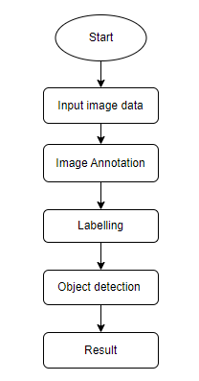
Figure- 2.4

2.5 ARCHITECTURE:

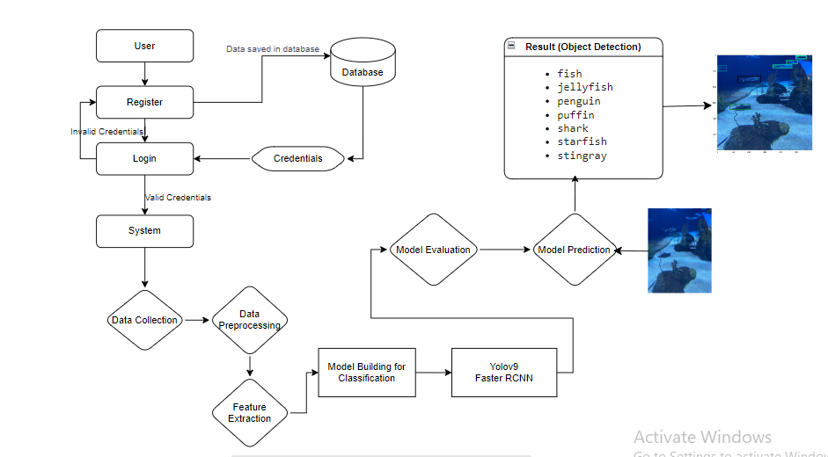
Figure- 2.5

3.SYSTEM REQUIREMENTS SPECIFICATION

SYSTEM REQUIREMENTS SPECIFICATION
3.1 SOFTWARE REQUIREMENTS:
Operating System : Windows 7/8/10/11
Server-side Script : HTML, CSS, Bootstrap & JS
Programming Language : Python
Libraries : Flask, Torch, Tensorflow, Pandas, Mysql connector
IDE/Workbench : VSCode
Server Deployment : Xampp Server
Database : MySQL

3.2 HARDWARE REQUIREMENTS:
Processor : I3/Intel Processor(min)
RAM : 8GB (min)
Hard Disk : 128 GB
Key Board : Standard Windows Keyboard
Mouse : Two or Three Button Mouse
Monitor : Any

3.3 FUNCTIONAL REQUIREMENTS:
- Fish Detection and Classification: The system must accurately detect fish within underwater images and classify them by species.
- Image Preprocessing: The system should preprocess images to improve visibility, manage lighting variations, and reduce noise from particulate matter for enhanced detection accuracy.
- Adaptability to Species Variability: The model should be capable of detecting and classifying multiple fish species of varying sizes, shapes, and behaviours.

3.4 NON-FUNCTIONAL REQUIREMENTS:
- Performance and Efficiency: The system must be optimized for high performance, reducing computational load to maintain efficiency in real-time scenarios.
- Scalability: The architecture should allow for scalability, making it adaptable to varying volumes of data and allowing deployment on different hardware platforms.
- Energy Efficiency: The system must conserve energy, particularly in battery-operated environments, to maximize operational time during underwater exploration.

4. SYSTEM DESIGN
SYSTEM DESIGN
4.1 INTRODUCTION:
Input Design:
In an information system, input is the raw data that is processed to produce output. During the input design, the developers must consider the input devices such as PC, MICR, OMR, etc.
Therefore, the quality of system input determines the quality of system output. Well-designed input forms and screens have following properties −
- It should serve specific purpose effectively such as storing, recording, and retrieving the information.
- It ensures proper completion with accuracy.
- It should be easy to fill and straightforward.
- It should focus on user’s attention, consistency, and simplicity.
- All these objectives are obtained using the knowledge of basic design principles regarding −
  - What are the inputs needed for the system?
  - How end users respond to different elements of forms and screens.

Objectives of Input Design:
The objectives of input design are −
- To design data entry and input procedures
- To reduce input volume
- To design source documents for data capture or devise other data capture methods
- To design input data records, data entry screens, user interface screens, etc.
- To use validation checks and develop effective input controls.

Output Design:
The design of output is the most important task of any system. During output design, developers identify the type of outputs needed, and consider the necessary output controls and prototype report layouts.

Objectives of Output Design:
The objectives of output design are:
- To develop output design that serves the intended purpose and eliminates the production of unwanted output.
- To develop the output design that meets the end user’s requirements.
- To deliver the appropriate quantity of output.
- To form the output in appropriate format and direct it to the right person.
- To make the output available on time for making good decisions.

4.2 UML DIAGRAMS AND DATAFLOW DIAGRAMS:
4.2.1 USE CASE DIAGRAM:
A use case diagram in the Unified Modeling Language (UML) is a type of behavioral diagram defined by and created from a Use-case analysis. Its purpose is to present a graphical overview of the functionality provided by a system in terms of actors, their goals (represented as use cases), and any dependencies between those use cases. The main purpose of a use case diagram is to show what system functions are performed for which actor. Roles of the actors in the system can be depicted.

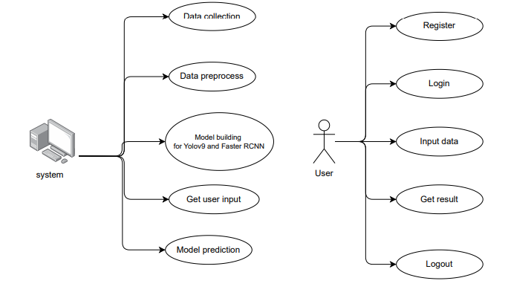
Figure – 4.2.1

4.2.2 CLASS DIAGRAM:
In software engineering, a class diagram in the Unified Modeling Language (UML) is a type of static structure diagram that describes the structure of a system by showing the system's classes, their attributes, operations (or methods), and the relationships among the classes. It explains which class contains information.

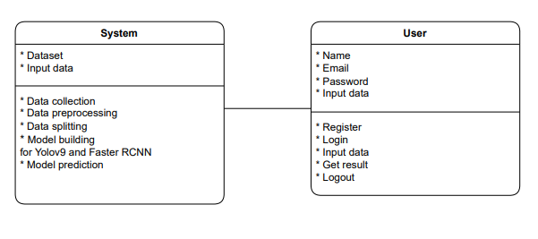
Figure – 4.2.2

4.2.3 SEQUENCE DIAGRAM:
A sequence diagram in Unified Modeling Language (UML) is a kind of interaction diagram that shows how processes operate with one another and in what order. It is a construct of a Message Sequence Chart. Sequence diagrams are sometimes called event diagrams, event scenarios, and timing diagrams.

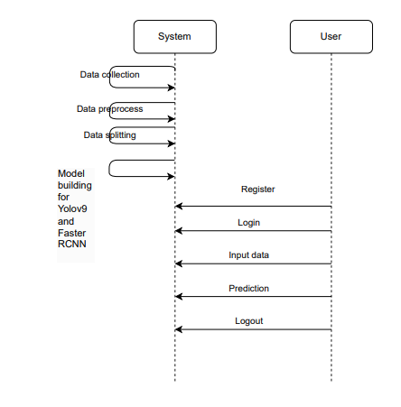
Figure – 4.2.3

4.2.4 COLLABORATION DIAGRAM:
In collaboration diagram the method call sequence is indicated by some numbering technique as shown below. The number indicates how the methods are called one after another. We have taken the same order management system to describe the collaboration diagram. The method calls are similar to that of a sequence diagram. But the difference is that the sequence diagram does not describe the object organization whereas the collaboration diagram shows the object organization.
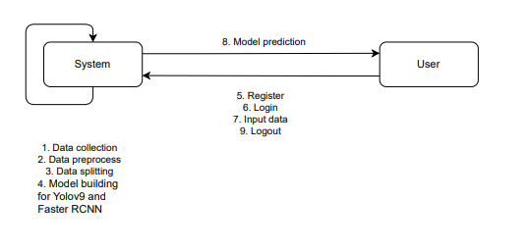
Figure – 4.2.4
4.2.5 DEPLOYMENT DIAGRAM
Deployment diagram represents the deployment view of a system. It is related to the component diagram. Because the components are deployed using the deployment diagrams. A deployment diagram consists of nodes. Nodes are nothing but physical hardware’s used to deploy the application.
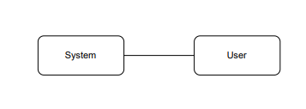
Figure – 4.2.5

4.2.6 COMPONENT DIAGRAM:
A component diagram, also known as a UML component diagram, describes the organization and wiring of the physical components in a system. Component diagrams are often drawn to help model implementation details and double-check that every aspect of the system's required functions is covered by
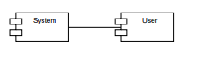
Figure – 4.2.6
4.2.7 ACTIVITY DIAGRAM:
Activity diagrams are graphical representations of workflows of stepwise activities and actions with support for choice, iteration and concurrency. In the Unified Modeling Language, activity diagrams can be used to describe the business and operational step-by-step workflows of components in a system. An activity diagram shows the overall flow of control.
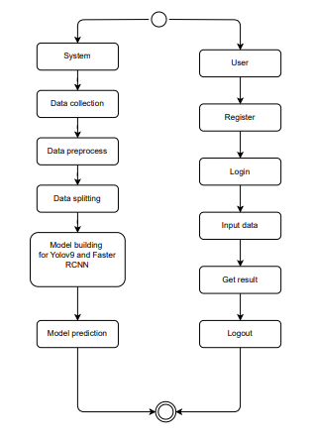
Figure – 4.2.7
4.2.8 DFD DIAGRAM
A Data Flow Diagram (DFD) is a traditional way to visualize the information flows within a system. A neat and clear DFD can depict a good amount of the system requirements graphically. It can be manual, automated, or a combination of both. It shows how information enters and leaves the system, what changes the information and where information is stored. The purpose of a DFD is to show the scope and boundaries of a system as a whole. It may be used as a communications tool between a systems analyst and any person who plays a part in the system that acts as the starting point for redesigning a system.

Context Diagram:

System

Data Store

User

Figure – 4.2.8.1

DFD Level-1 Diagram:
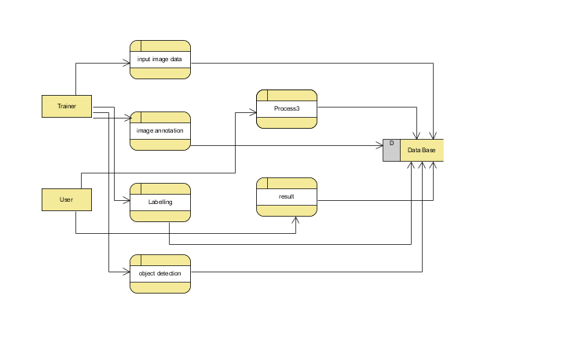
Figure – 4.2.8.2
DFD Level-2 Diagram:
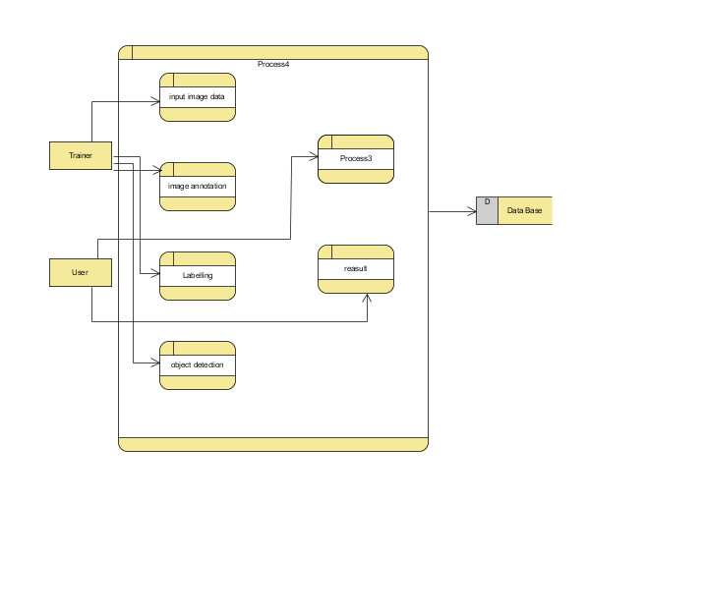
Figure – 4.2.8.3
4.3 DATABASE DESIGN
4.3.1 ER DIAGRAM
An Entity–relationship model (ER model) describes the structure of a database with the help of a diagram, which is known as Entity Relationship Diagram (ER Diagram).
An ER diagram shows the relationship among entity sets. An entity set is a group of similar entities and these entities can have attributes.
In terms of DBMS, an entity is a table or attribute of a table in database, so by showing relationship among tables and their attributes, ER diagram shows the complete logical structure of a database.

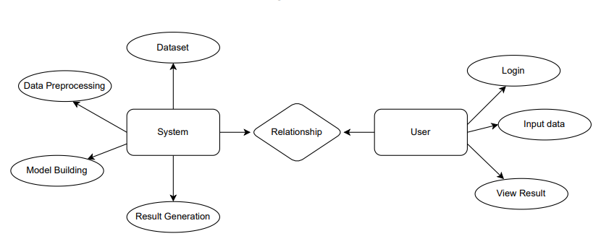
Figure – 4.3.1

4.3.2 TABLE STRUCTURES
Users Table
Purpose: The users table stores information about registered users, enabling authentication and access control.

Table Schema:

Column Name | Data Type | Constraints | Description
id | INT (PK, AI) | PRIMARY KEY,  AUTO_INCREMENT | Unique identifier for each user
name | VARCHAR(100) | NOT NULL | User’s full name
email | VARCHAR(255) | UNIQUE, NOT NULL | User’s email (used for login)
password | VARCHAR(255) | NOT NULL | User’s encrypted password

5. SYSTEM IMPLEMENTATION

SYSTEM IMPLEMENTATION

5.1 INTRODUCTION:
The implementation phase involves putting the project plan into action. It is here where we should check whether the objectives of the project are met. The implementation phase is where we do the project work to produce the deliverables. The deliverables must include the products or services that the team are performing for the user including all the project management documents that you put together.
In our project “Enhanced Underwater Fish Detection: A Comparative Study of YOLOv9 and Faster RCNN”, the user has to follow the below steps in order to use the application.
The steps are:
- After successful entry to the home page, the user has to register in order to use the application.
- Before registration the user can actually navigate to About section to understand many details about the application.
- During the registration, the user has to specify credentials like name, email ID and password. The registration page is built with certain constraints like All the fields are mandatory, email ID must include “@”, both password and confirm password fields must match. If the user failed to meet the constraints, warnings will be generated.
- Upon successful registration, the user has to login in order to proceed further. The login includes fields like mail and password. As soon as login is successful, the user can now access the application.
- After login, the user can access different modules like upload and logout.
- By using upload module, the user can upload any image containing fish or fishes for the system to detect fish location and the species among fish, starfish, jellyfish, penguin, puffin, stingray, shark.
- After uploading the image, the system will display the fish location in bounding boxes and the species are described with the name along with a confidence score. The confidence score determines that the system is confident to that extent about the detection as well as classification.
- At the end the user can freely logout from the system by clicking on logout module.

5.2 PROJECT MODULES:
The project modules include both system and user modules.
5.2.1 System modules:
5.2.1.1 Fish Detection:
- Collects input: Utilizes underwater images as input for fish detection.
- Develop a user interface: For uploading an image and viewing underwater fish detection, classification.
- Implement detection methods: Utilize Faster R-CNN and YOLOv9 models to identify fish within media files accurately.
5.2.1.2 Species Classification:
- Classifies detected fish: Based on visual features extracted by the detection models the fishes are classified into various species such as fish, starfish, jellyfish, penguin, puffin, stingray, shark. The confidence score is also generated.
- Develop algorithms: For accurate classification of fish species from a predefined list, YOLOv9 and Faster RCNN algorithms are developed.
5.2.2 User Modules:
- Register: Users must first register with their credentials to create an account in the system.
- Login: Users can log in with their registered credentials to access the system and its features.
- About: Users can know more details about the pro
- Upload image: Users can upload under water fish images for prediction.
- Viewing Results: User can see prediction in the segmented image in our project’s result page.
- Logout: Users can log out of the system to secure their session and personal data.

Data Preprocessing
Data Collection

Data Augmentation

Model Implementation

Model Training and Evaluation

Deployment and Testing

Figure-5.1

In the above Figure-5.1 we can see the flow of our proposed system, how it works and we can also know how one module depends on other, the order and relation between the modules.

Data Collection:
The dataset is collected from Roboflow and the dataset used is “Aquarium Combined”. The dataset utilized for this project comprises a diverse collection of underwater images, specifically curated to represent seven distinct marine species: Fish, jellyfish, penguin, puffin, shark, starfish and sting ray. It helps to make the model more versatile during training, thus providing for correct identification of these water creatures in their natural environments. The dataset comprises of 638 images which are further split into 448 (70%) train, 127(20%) valid, 63(10%) test images.

Data Preprocessing:
- Image Resizing:
Image resizing is the process of changing the dimensions (height and width) of an image while maintaining its content. Resizing is necessary in deep learning because models require fixed input sizes for batch processing. It ensures uniform input size for neural networks, reduces computational cost (smaller images → faster training) and helps models learn patterns from consistent feature sizes.
- Horizontal Flipping:
It is a technique that mirrors an image along the vertical axis (left ↔ right). In this each pixel is mapped to its opposite position on the x-axis. For example, A fish swimming left will now swim right after flipping. It prevents overfitting by introducing new variations and helps models generalize better to different orientations. It is useful when objects don’t have a fixed left/right orientation.
- Vertical Flipping:
It is a technique that is similar to horizontal flipping but it mirrors an image along the horizontal axis (top ↔ bottom). In this each pixel is mapped to its opposite position on the y-axis. For example, A fish above in an image will now be below after flipping. It prevents overfitting by increasing dataset variability. It helps the model recognize objects regardless of their placement in the image. It is useful for marine life and underwater imagery, where objects can appear in different orientations.
- Random Brightness & Contrast Adjustment:
As underwater images suffer from lighting variations due to water depth, turbidity, and light refraction, this technique is used to improve the model’s ability to detect fish in different brightness conditions. It adds a value to all pixels to make the image brighter or darker and adjusts pixel intensities to make edges sharper or softer. It helps to generalize across different environments (e.g., clear water vs. deep ocean) and lighting conditions (e.g., sunlight, murky water, deep-sea darkness).
- Colour Jitter:
As water colour varies significantly based on location and depth, this technique randomly modifies brightness, contrast, saturation, and hue to simulate colour variations. It lightens or darkens the image, enhances or reduces differences between light/dark areas, makes colours more or less vivid and changes the overall tint. It helps the model adapt to real-world colour variations in underwater images which are caused due to algae, sunlight, and depth.

Data Augmentation:
The dataset is artificially expanded using data augmentation techniques. Transformations like rotation, flipping, zooming, or adjustments in brightness are applied to existing images. Data augmentation enhances dataset diversity and improves the model's ability to generalize.

Model Implementation:
- YOLOv9 Implementation: It utilizes a single-stage detection pipeline with real-time inference capabilities. It has backbone, neck and head for feature extraction, feature fusion, bounding box generation and species classification respectively. It uses PyTorch framework for implementation. It is trained by using pre-trained weights on COCO and optimized with data augmentation and hyperparameter tuning (batch size, learning rate, IoU threshold).

- Faster RCNN Implementation: It utilizes two-stage object detection model using Region Proposal Network (RPN) and Faster RCNN detector. RPN proposes a location where fish might be located in the image and later the detector will accurately identify and classify the fish in the regions that are proposed by RPN. The Mobile Net will act as a backbone network in this and improves the system's ability to accurately identify and classify a wide range of fish species. It is trained by using pre-trained weights on ImageNet and optimized with data augmentation and hyperparameter training.

Model Training and Evaluation:
Model Training: Training is a fundamental process in deep learning where the model gains knowledge from labelled data and make accurate predictions on unseen data. Training is necessary to enable the model to recognize patterns and associations within the data, allowing it to make informed decisions. During training, models learn to extract increasingly complex and meaningful features from raw input data(images), by iteratively transforming the data through multiple layers of non-linear transformations. In the context of Enhanced Under Water Fish Detection, training the models with a diverse dataset helps them to learn the features associated with different species of fish. The models YOLOv9 and Faster RCNN are trained in the backend by using train dataset that has 448 images with various aquatic environments and various species. GPU acceleration (NVIDIA CUDA) is used to speed up training.

Model Evaluation: Once both the models are trained, their performances are evaluated based on metrics such as Training value, Precision, Recall, False Positives and False Negatives, mAP for detection accuracy, IOU for bounding box accuracy. Considering all the metrics Faster RCNN is considered as the best model for under water fish detection. So, in the front end, Faster RCNN is used for fish detection and species classification.

Deployment and Testing:
The model is deployed and tested on various images to ensure that the system works well in any given environment. The system is tested by providing an image which is not given during training. The model will accurately identify the location of fish using anchor boxes or bounding boxes and the species will be classified with a confidence score.

5.3 ALGORITHMS:
    - YOLOv9:
- YOLOv9 (You Only Look Once Version 9) utilizes a one-stage detection approach, directly predicting bounding boxes and class probabilities from the input image at one go. This significantly reduces processing time and enhances real-time detection capabilities.
- YOLOv9 employs a modular design that includes a backbone for feature extraction, a neck for feature fusion, and a head for making final detection predictions. This structure allows for efficient processing and accurate detection of objects in images.
- The algorithm is designed to detect objects at multiple scales, enabling it to identify small and large objects effectively. This is particularly useful in environments with varying object sizes, such as underwater scenes with diverse fish species.
- YOLOv9 incorporates various data augmentation strategies to improve robustness against challenges like lighting variations and background noise. These techniques enhance the model's ability to generalize across different conditions, resulting in higher detection accuracy.

- Input Image: The process begins with an input image, which is pre-processed to fit the model's expected dimensions.
- Feature Extraction: The backbone network extracts hierarchical features from the image. This stage captures important visual information essential for detecting objects.
- Feature Fusion: The neck of the network combines features from different scales, allowing the model to retain spatial information and improve the accuracy of detection across various object sizes.
- Bounding Box Prediction: The head of the network generates predictions for bounding boxes and class probabilities for each detected object in the image. These predictions indicate the location and category of the objects.
- Post-Processing: After generating predictions, post-processing steps such as non-maximum suppression (NMS) are applied to eliminate redundant overlapping boxes, ensuring that each object is represented accurately.
- Output: The final output includes the processed image with annotated bounding boxes around detected objects and their corresponding class labels, ready for visualization or further analysis.

    - Faster RCNN:
- Faster R-CNN employs a two-stage detection framework consisting of a Region Proposal Network (RPN) and a Fast R-CNN detector. The first stage generates region proposals where objects may be located, while the second stage classifies these proposals and refines their bounding box coordinates.
- The RPN is a key component that efficiently generates object locations directly from feature maps, using anchor boxes of various scales and aspect ratios. This allows the model to propose regions likely to contain objects, improving detection speed.
- Both the RPN and the detection network share the same convolutional feature map, significantly reducing computation time compared to traditional methods that use separate feature extraction processes for region proposal and classification.
- Faster R-CNN's architecture is designed to be robust against variations in object size, shape, and background noise, making it effective for detecting objects in complex environments, such as underwater scenes with diverse fish species.

- Input Image: The process begins with an input image that is resized and normalized to fit the model's input requirements.
- Feature Extraction: A backbone network (such as ResNet or VGG) extracts deep features from the input image. This feature map contains important visual information used for both region proposals and object classification.
- Region Proposal Network (RPN): The RPN takes the feature map as input and generates a set of region proposals, predicting the potential bounding boxes and their corresponding objectness scores using anchor boxes of different scales and aspect ratios.
- Proposal Refinement: The region proposals generated by the RPN are filtered based on their objectness scores, and the remaining proposals are passed to the Fast R-CNN detector for further processing.
- Object Classification and Bounding Box Regression: The Fast R-CNN component classifies the filtered proposals and refines their bounding box coordinates. This step involves using the features from the shared convolutional feature map to accurately identify and localize the detected objects.
- Post-Processing: Non-maximum suppression (NMS) is applied to remove overlapping bounding boxes, ensuring that each detected object is represented by a single bounding box with the highest confidence score.
- Output: The final output includes the processed image with annotated bounding boxes around detected objects, along with their corresponding class labels and refined coordinates, ready for visualization or further analysis.

5.4 SCREENS:
5.4.1 Landing Page
This screen (Figure- 5.4.1) serves as the main landing page of the underwater fish detection system. It introduces the platform's core functionality—leveraging deep learning for the accurate identification and categorization of fish species. The page guides users to easily navigate different sections, such as registration, login, and detection.
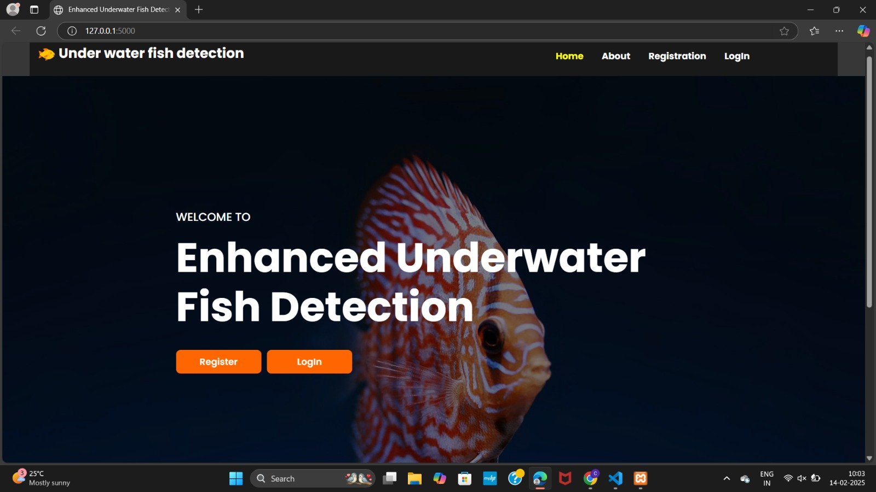
Figure- 5.4.1

5.4.2 About Page
This page (Figure-5.4.2) introduces the project's focus on underwater fish detection using Faster R-CNN and YOLOv9, addressing challenges like varying lighting, water turbidity, and occlusions. It explains how these models are applied for real-time fish identification and localization.
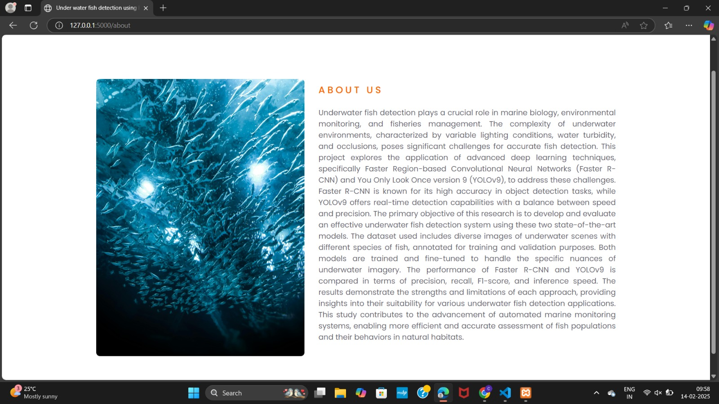
Figure- 5.4.2

5.4.3 Registration Page
The registration page (Figure-5.4.3) allows users to create an account by providing their name, email, password, and confirmation password. This form is designed for easy user onboarding to the fish detection system.
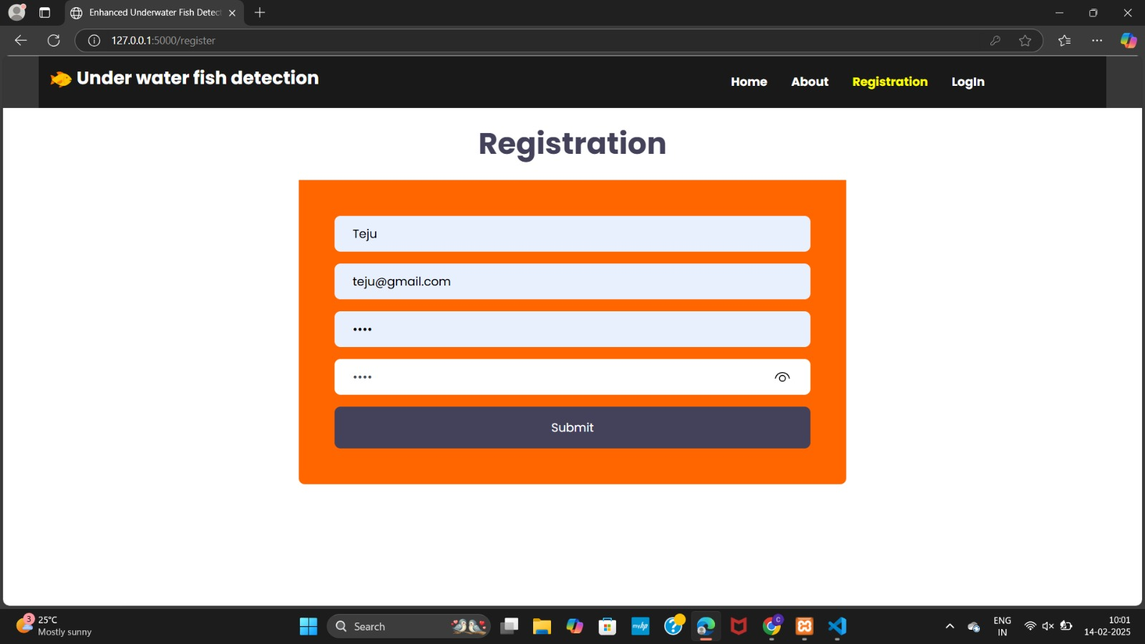
Figure- 5.4.3
5.4.4 Login Page
The login page (Figure-5.4.4) provides users with a simple interface to access their accounts by entering their registered email and password. It ensures secure access to the system's functionalities.
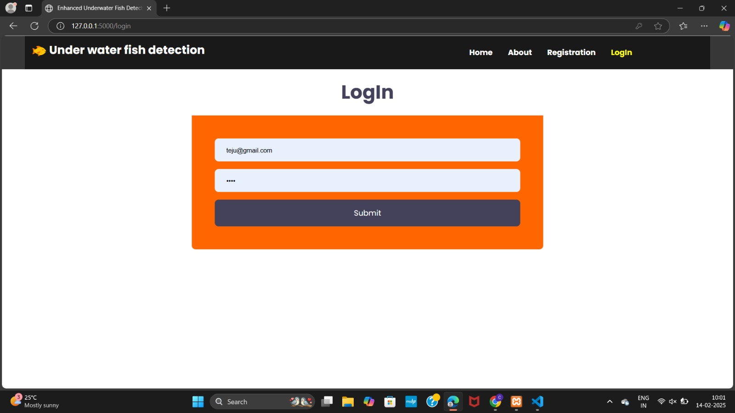
Figure- 5.4.4
5.4.5 Home page
The home page (Figure-5.4.5) welcomes users to the underwater fish detection system for detecting fish in underwater environments. It sets the stage for users to start interacting with the platform.
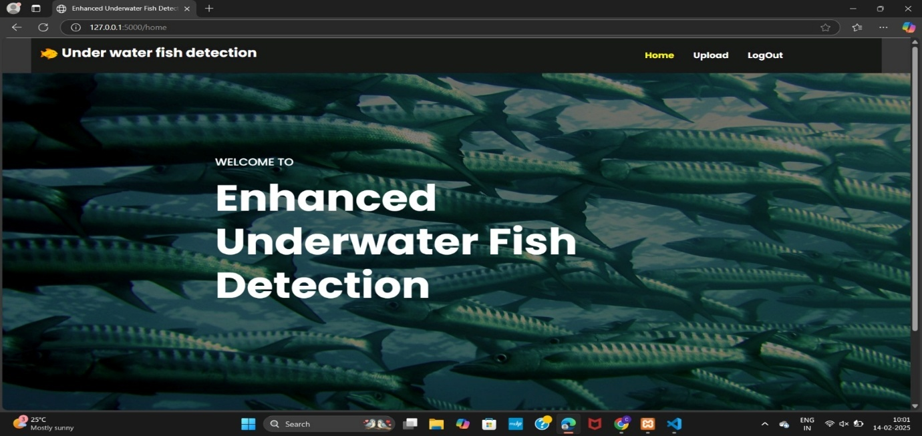
Figure- 5.4.5
5.4.6 Upload page
The upload page (Figure-5.4.6) allows users to upload images for fish detection. Once an image is submitted, the system processes it using the integrated detection models and displays the results.
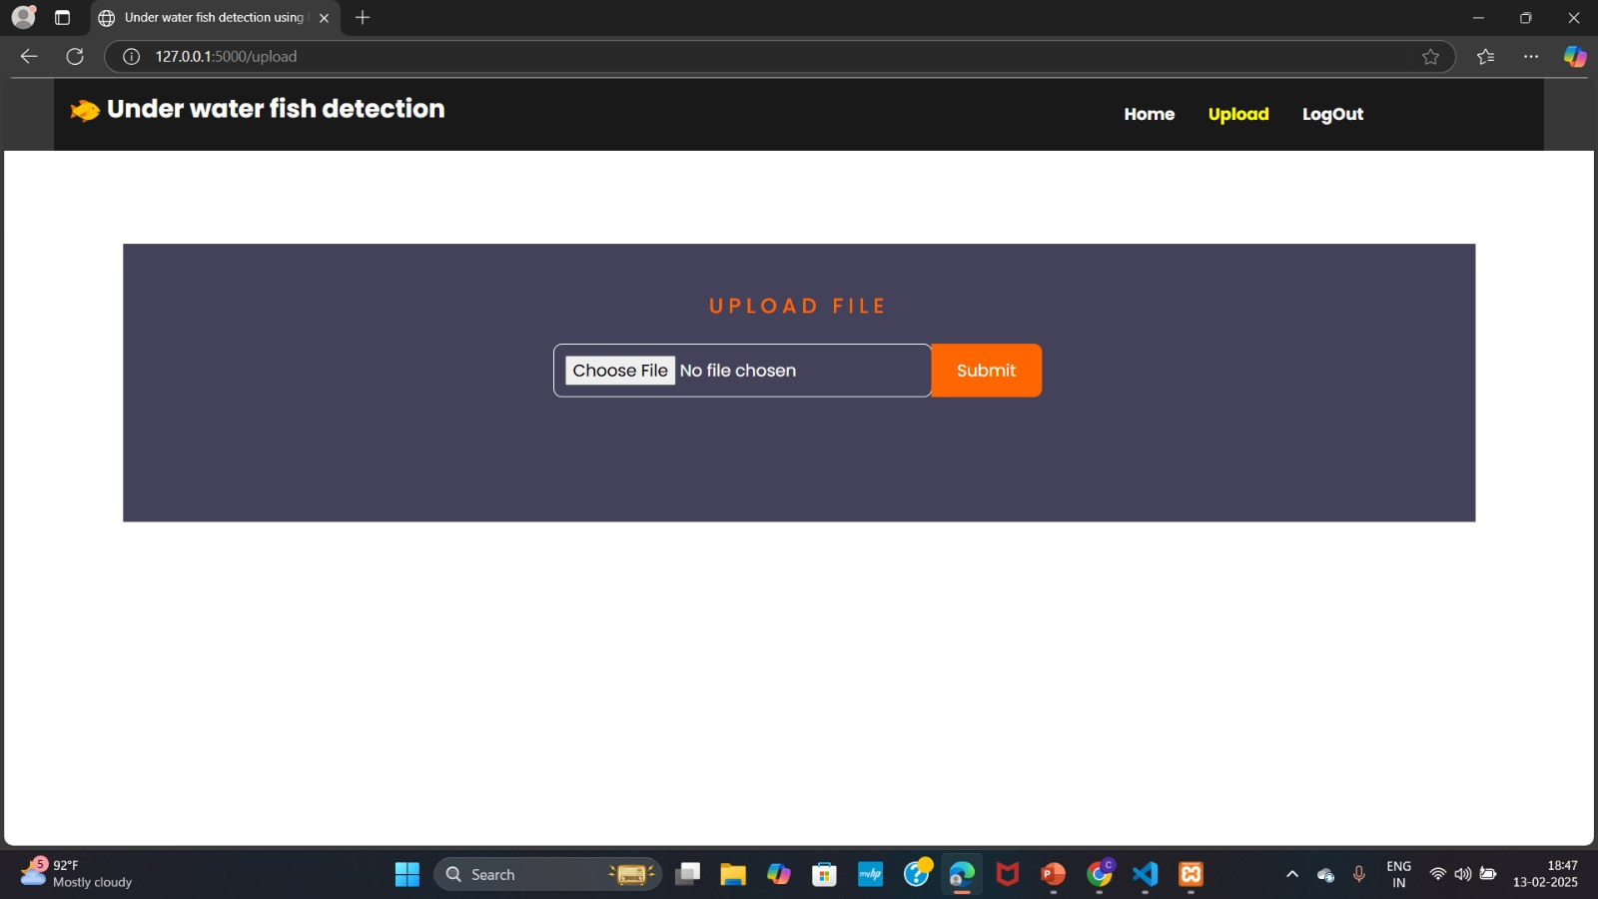
Figure- 5.4.6
5.4.7 Detection Results Page
This page shows the output of the fish detection process, displaying the image with bounding boxes around detected fish and confidence scores, visualizing the effectiveness of the detection model (Faster RCNN).
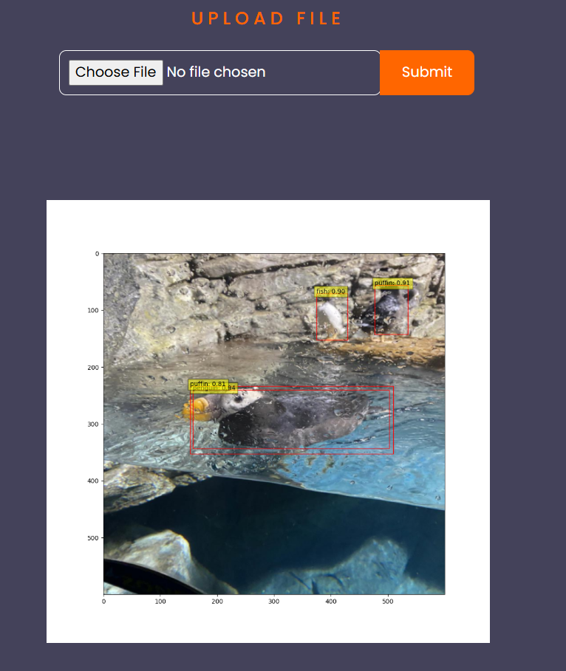
Figure- 5.4.7.1
Figure- 5.4.7.2
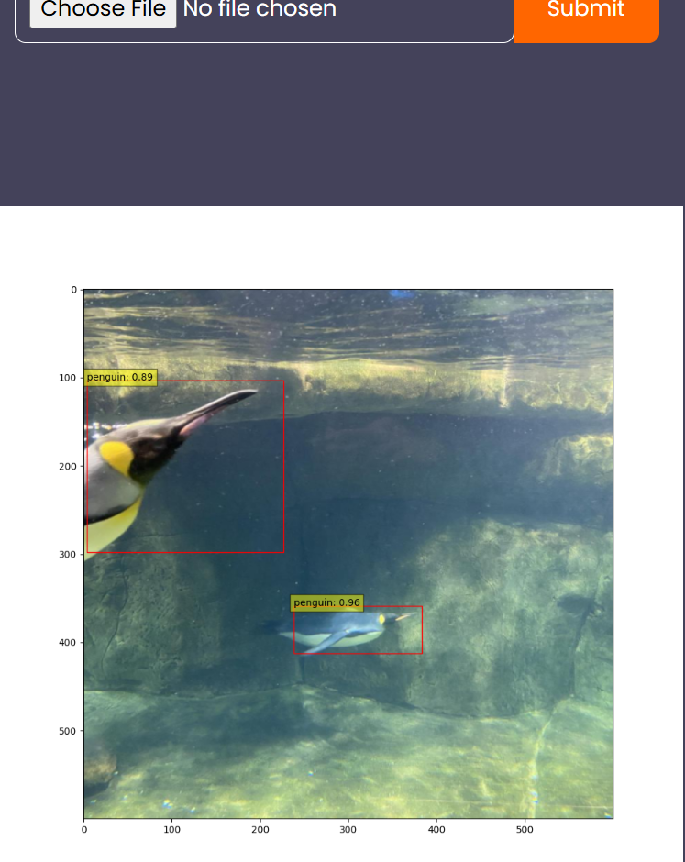
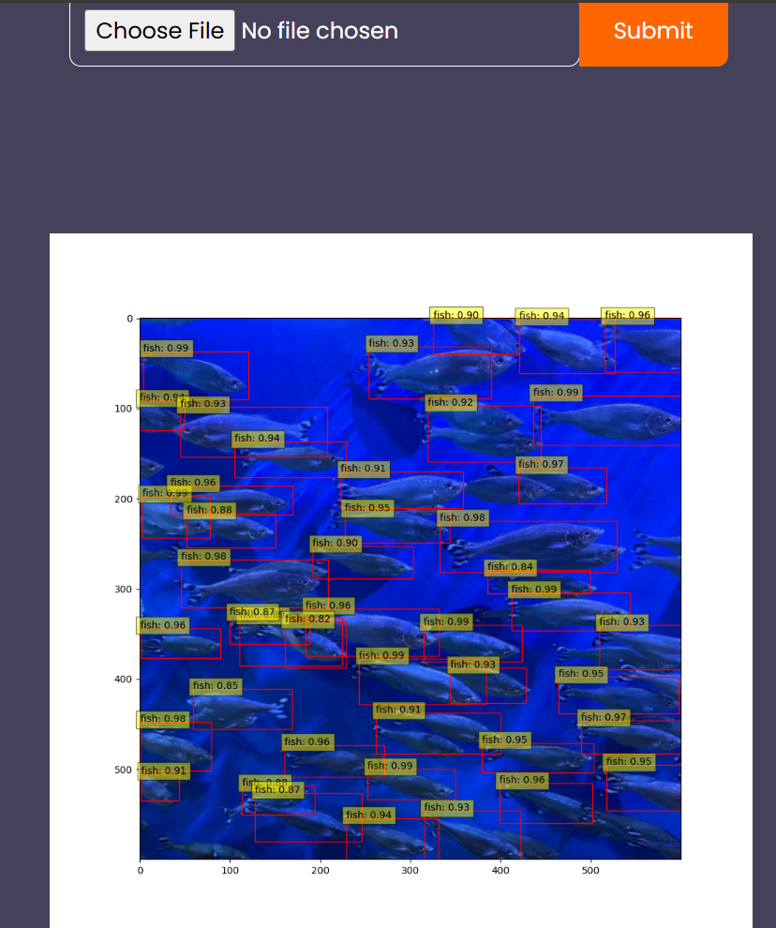
Figure- 5.4.7.3
Figure- 5.4.7.4
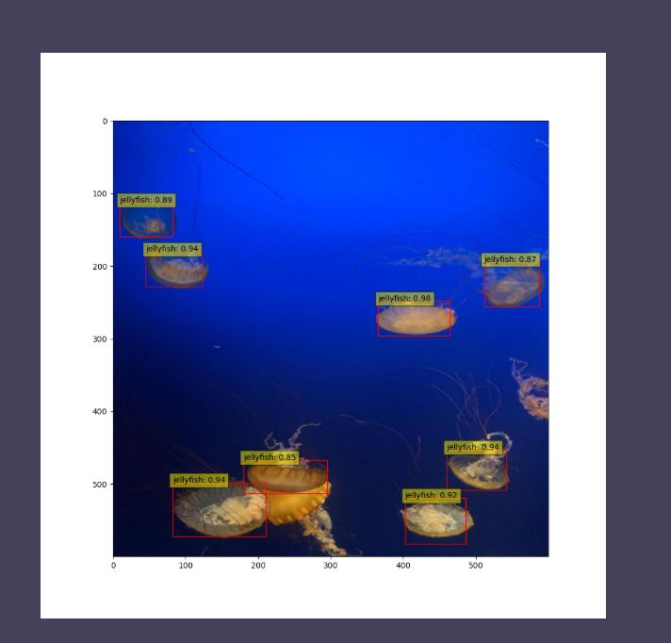
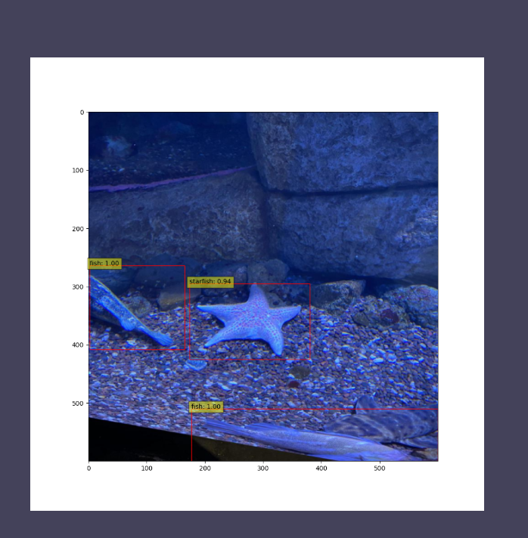
Figure- 5.4.7.5
Figure- 5.4.7.6
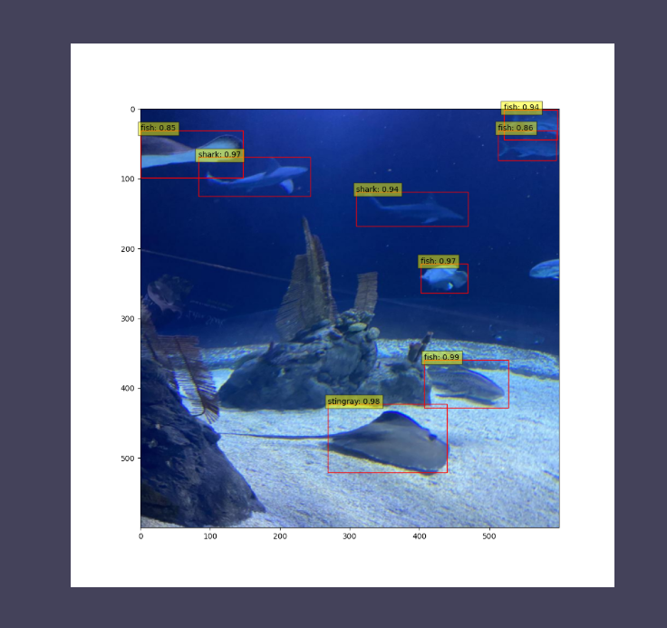
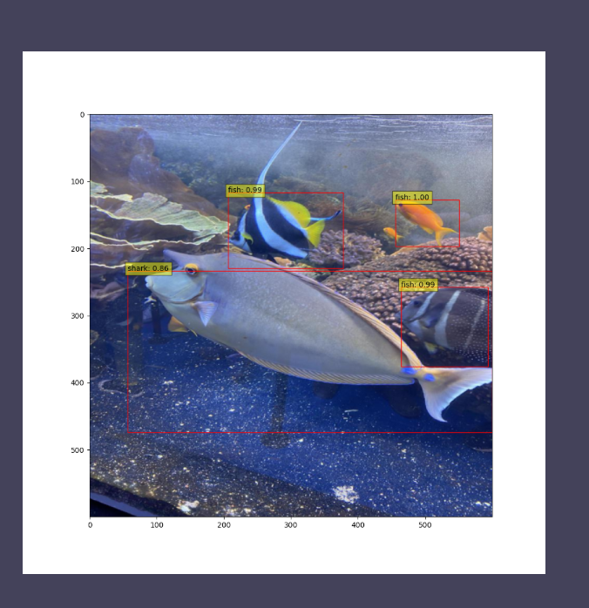
Figure- 5.4.7.7

6.SYSTEM TESTING

SYSTEM TESTING
6.1 INTRODUCTION:
System Testing is a software testing phase where the entire system (software + hardware) is tested as a whole to ensure it meets the specified requirements. It is conducted after integration testing and before acceptance testing. System testing verifies that the application functions correctly across different environments, ensuring end-to-end validation of business requirements.
The purpose of testing is to discover errors. Testing is the process of trying to discover every conceivable fault or weakness in a work product. It provides a way to check the functionality of components, sub-assemblies, assemblies and/or a finished product It is the process of exercising software with the intent of ensuring that the software system meets its requirements and user expectations and does not fail in an unacceptable manner. There are various types of tests. Each test type addresses a specific testing requirement.
The objectives of system testing are:
- Verify that all integrated components function correctly.
- Ensure the system meets functional and non-functional requirements.
- Identify defects before deployment.
- Validate that the system works under real-world conditions.
- Test the system's interaction with external dependencies like databases, APIs, and other services.
The process of system testing is:
- Test Planning
- Define test strategy, objectives, and scope.
- Identify required tools and test environments.
- Allocate resources and define schedules.
- Test Case Development
- Create detailed test cases based on requirements.
- Prepare test data for various scenarios.

- Test Environment Setup
- Configure hardware, software, network, and database.
- Test Execution
- Run test cases and record results.
- Identify and log defects.
- Defect Tracking and Reporting
- Report bugs and track their resolution.
- Retest fixes and perform regression testing.
- Test Closure
- Prepare test summary reports.
- Review lessons learned for future improvements.
The benefits of system testing are:
1. Improves software quality, reliability, and security.
2. Reduce overall cost and time
3. Detects defects early.
4. Enhances user satisfaction by identifying usability issues.
6.2 TESTING METHODS
    - UNIT TESTING
Unit Testing involves the design of test cases that validate that the internal program logic is functioning properly, and that program inputs produce valid outputs. All decision branches and internal code flow should be validated. It is the testing of individual software units of the application .it is done after the completion of an individual unit before integration. This is a structural testing, that relies on knowledge of its construction and is invasive. Unit tests perform basic tests at component level and test a specific business process, application, and/or system configuration. Unit tests ensure that each unique path of a business process performs accurately to the documented specifications and contains clearly defined inputs and expected results.

    - INTEGRATION TESTING
Integration tests are designed to test integrated software components to determine if they actually run as one program. Testing is event driven and is more concerned with the basic outcome of screens or fields. Integration tests demonstrate that although the components were individually satisfaction, as shown by successfully unit testing, the combination of components is correct and consistent. Integration testing is specifically aimed at exposing the problems that arise from the combination of components.
Software integration testing is the incremental integration testing of two or more integrated software components on a single platform to produce failures caused by interface defects. The task of the integration test is to check that components or software applications interact without any error, e.g. components in a software system or one step up software applications at the company level.
    - ACCEPTANCE TESTING
User acceptance Testing is a critical phase of any project and requires significant participation by the end user. It also ensures that the system meets the functional requirements.
    - FUNCTIONAL TESTING
Functional tests provide systematic demonstrations that functions tested are available as specified by the business and technical requirements, system documentation, and user manuals.
Functional testing is centred on the following items:
Valid Input : identified classes of valid input must be accepted.
Invalid Input : identified classes of invalid input must be rejected.
Functions : identified functions must be exercised.
Output : identified classes of application outputs must be exercised.
Systems/Procedures : interfacing systems or procedures must be invoked.

Organization and preparation of functional tests is focused on requirements, key functions, or special test cases. In addition, systematic coverage pertaining to identify Business process flows; data fields, predefined processes, and successive processes must be considered for testing. Before functional testing is complete, additional tests are identified and the effective value of current tests is determined.
    - White Box Testing
White Box Testing is a testing in which in which the software tester has knowledge of the inner workings, structure and language of the software, or at least its purpose. It is purpose. It is used to test areas that cannot be reached from a black box level.
    - Black Box Testing
Black Box Testing is testing the software without any knowledge of the inner workings, structure or language of the module being tested. Black box tests, as most other kinds of tests, must be written from a definitive source document, such as specification or requirements document, such as specification or requirements document. It is a testing in which the software under test is treated, as a black box. you cannot “see” into it. The test provides inputs and responds to outputs without considering how the software works.
Test objectives
- All field entries must work properly.
- Pages must be activated from the identified link.
- The entry screen, messages and responses must not be delayed.
Features to be tested
- Verify that the entries are of the correct format
- No duplicate entries should be allowed
- All links should take the user to the correct page.

6.3 TEST CASES
Registration Criteria:
- In the registration page, user has to give his name, email id, create a password and confirm the password.
- The conditions that we have included are:
- The email id should contain ‘@’.
- The user has to fill all the fields.
- The password and confirm password fields must match.
- The user cannot register with the same email id more than once.
- The user must follow above criteria to register otherwise our system tries to give warning messages through which user can able to give correct data for registration.
Login Criteria:
- We have constructed our system login criteria in such a way that user must give proper data that he has given at the time of registration.
- If he gives any unmatched data our system raises warning messages and will not allow the user to proceed further.
- The conditions that we included are:
- The email id and password during login, must be matched with the details given during registration.
- Entering wrong password will terminate the login.
- Entering an email id which is not registered will lead to warning messages.
Validation Criteria:
- The image which user uploads, will be given to the system.
- The system evaluates the given input image and based on features upon which it is trained, it will detect the location of the fish accurately using bounding boxes and also classifies the species of fish with a confidence score.

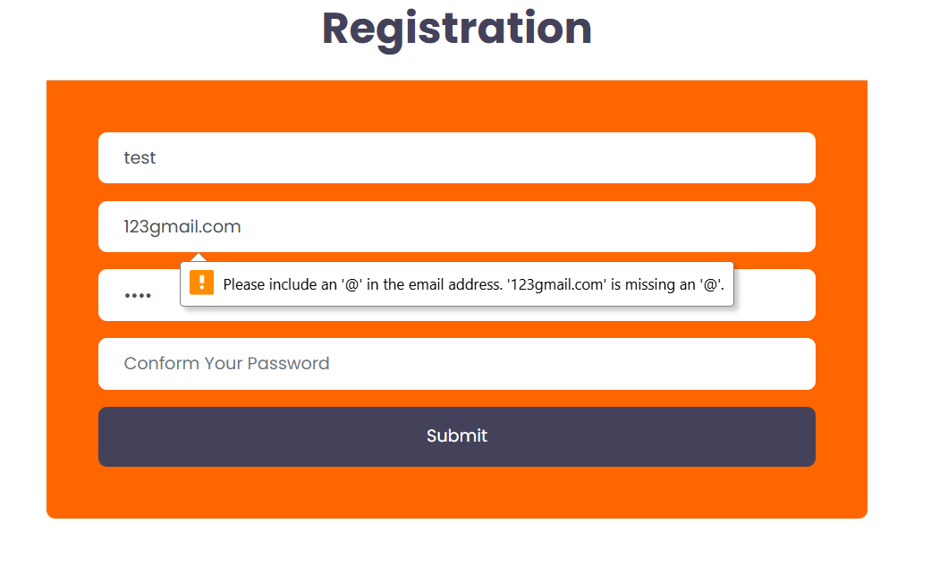
Figure- 6.3.1
The above Figure- 6.3.1 shows the registration page with alert message. This alert will be raised when user tried to fill any invalid email address to register themself. By this alert they will get to know their error and can able to register with correct email address format next time. Here, for validating email we are taking some considerations: The format of the email i.e., the system validation function checks whether the email id that is given contains ’@’. If the email address fails the check, the function raises an error indicating that the email address is not valid. Otherwise, if it passes the check, the email address is considered valid.
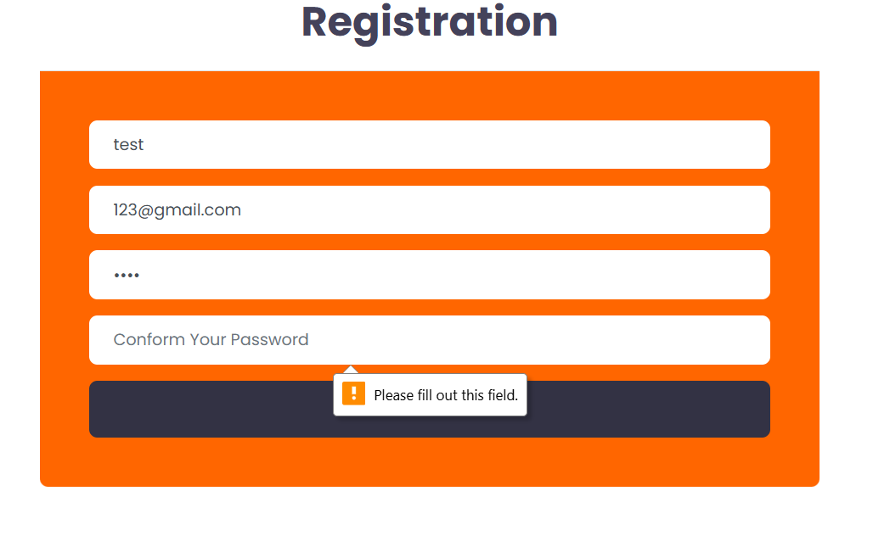
Figure- 6.3.2
The above Figure- 6.3.2 indicates that during registration all the fields are mandatory to be filled. If a user did not fill any of the specified fields, the system will generate a warning otherwise the registration will be completed if all the necessary conditions are met.
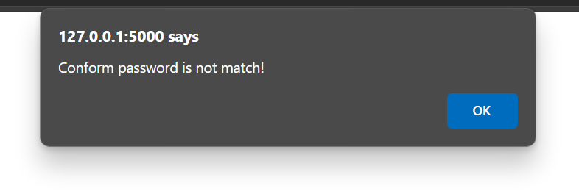
Figure- 6.3.3
The above Figure- 6.3.3 indicates that during registration, both the password and confirm password fields must match. Confirm password indicates that user need to confirm their password which he had given in password filed. So, these both should contain same password otherwise this alert will be raised.

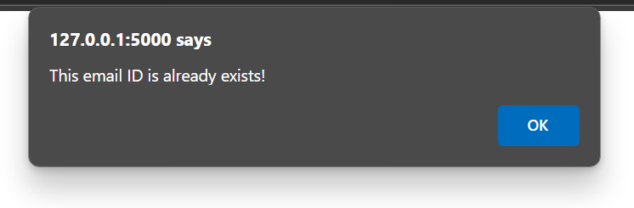
Figure- 6.3.4
The above Figure 6.3.4 indicates alert message that will be displayed when a user uses already registered email for a new registration. It means that a user already registered and he is again trying to register with same credentials which causes redundancy.

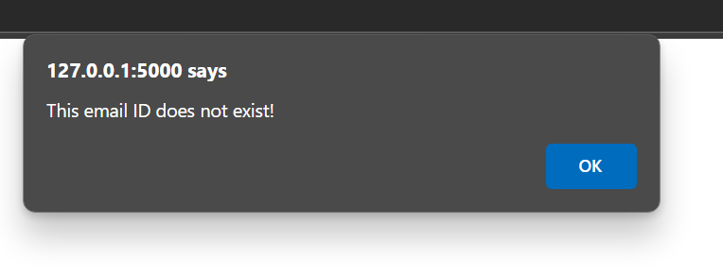
Figure- 6.3.5
The above Figure- 6.3.5 indicates a warning that will be displayed during login, when a user uses an email id that is not registered. During login, user must use registered email id only. So, the above warning is generated by the system when an unregistered email id is used to login.

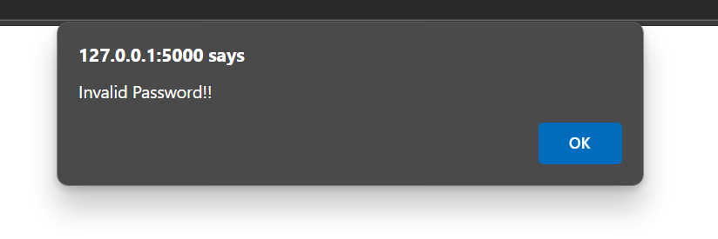
Figure- 6.3.6
The above Figure- 6.3.6 indicates a warning that will be displayed during login, when a user uses a wrong password. The user must login only with registered email id and password.

Input | Output | Result
Input | Tested for different inputs given by users. | Success
Model | Tested for different inputs given by the user on two models (Faster RCNN and YOLOv9), calculated and compared the performance metrics of both the models and have chosen the best model (Faster RCNN) | Success
Prediction | Prediction is performed using the model | Success

S.NO | Test cases | Input | Expected Output | Actual Output | Results
1 | Read the datasets. | Dataset path. | Dataset need to read successfully. | Dataset fetched successfully. | Success
2 | Registration | Valid username, email, password. | Verify that the registration form accepts valid user inputs and successfully creates a new account. | User is successfully registered, and an account is created | Success
3 | Login | Valid username and password | Verify that users log in with valid credentials | User is successfully logged in and redirected to the dashboard | Success
4 | Find out fish in under water images | Upload under water fish images | Give the location of fish in an image and classify the species | The fish location is indicated by bounding boxes and species are classified with a confidence score | Success

6.4 RESULTS
To compare the efficiency of the proposed system numerous experiments were performed on YOLOv9 model and Faster R-CNN architecture. These experiments were concerned with identifying various fish species in a given image. The two models were trained to identify marine species in order to compare their efficiency when tested under similar circumstances.
YOLOv9 Performance Metrics:
Class | Images | Instances | Precision (P) | Recall (R) |  | mAP50 | mAP50-95
all | 127 | 909 | 0.816 |  | 0.707 | 0.779 | 0.461
fish | 127 | 459 | 0.873 | 0.720 |  | 0.793 | 0.435
jellyfish | 127 | 155 | 0.850 | 0.871 |  | 0.919 | 0.535
penguin | 127 | 104 | 0.706 | 0.702 |  | 0.700 | 0.311
puffin | 127 | 74 | 0.754 | 0.568 |  | 0.668 | 0.322
shark | 127 | 57 | 0.783 | 0.632 |  | 0.687 | 0.427
starfish | 127 | 27 | 0.899 | 0.667 |  | 0.816 | 0.613
stingray | 127 | 33 | 0.846 | 0.788 |  | 0.867 | 0.582
YOLOv9 showed detection competency across all classes. Preciseness and recall scores were always kept high, ensuring the appropriate identification of marine species at varying scenarios. Among the classes considered in this study, jellyfish showed the highest mean Average Precision (mAP) values. The mAP50 reached 0.919 and mAP50-95 at 0.535. The performances of fish and stingray categories were also balanced to achieve high precision and recall values.
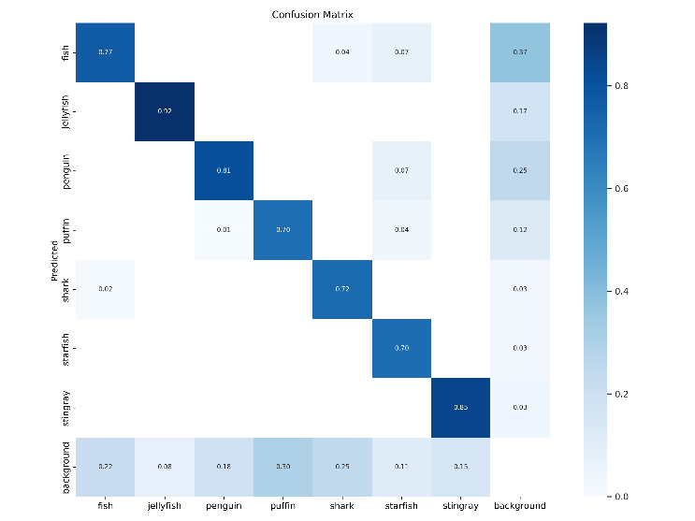
Figure- 6.4.1
The above confusion matrix (Figure- 6.4.1) determines the YOLOv9 model's performance in classification of marine species. On the diagonal, it will be a correct prediction of high accuracy for jellyfish (0.92), stingray (0.85), and fish (0.77). Errors are those that occur diagonally: fish mislabelled as background (0.37) or penguin (0.07). Some confusion appears between puffins and penguins, probably based on appearance. Sharks and starfish have moderate values (0.72 and 0.70). The background predictions overlap into multiple classes and indicate that separating objects from irrelevant areas is difficult. Overall performance is strong, but fine-tuning and data augmentation could improve underperforming classes and increase the reliability of the model.
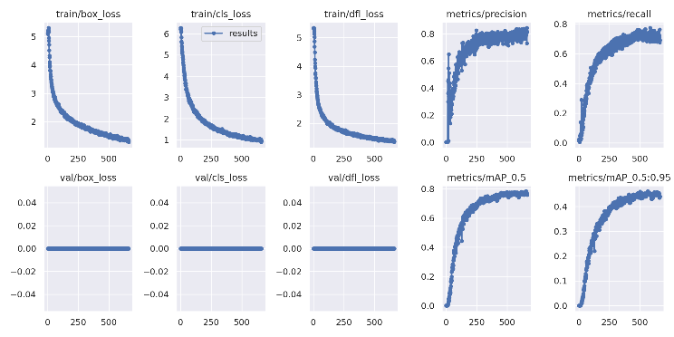
Figure- 6.4.2
The above graph (Figure- 6.4.2) is a summary of training and validation performance from YOLOv9. There's continuous reduction of training loss including box loss, class loss, as well as DFL and near to zero loss in validations, proving appropriate regularization and with minimal overfitting happening. This was a consistent trend in both precision and recalls. The metrics of mean Average Precision (mAP@0.5 and mAP@0.5:0.95) indicate steady growth, and the model's performance in object detection is robust to varying IoU thresholds. Overall, the results showcase the strength of YOLOv9 in its training and generalization over underwater species detection.
Faster RCNN Performance Metrics:
Metric | Faster R-CNN
Precision | 93.02%
Recall | 85.11%
Training Value | 85.71%
False Positive (FP) | 30
False Negative (FN) | 70

The results are high in terms of precision and recall, which implies that the model is capable of effectively detecting marine species, especially when objects are partially occluded or densely grouped. This further establishes its utility in realistic underwater scenarios.

Comparative Analysis:
Metric | YOLOv9 | Faster R-CNN
Precision | 81.6% | 93.02%
Recall | 70.7% | 85.11%
Training Value | 77.1% | 85.71%
False Positive (FP) | 124 | 30
False Negative (FN) | 229 | 70

The above experimental results prove that the YOLOv9 and Faster R-CNN models are valid for underwater fish detection, and both algorithms have their advantages. While detecting in real-time YOLOv9 shows great performance, in more complex conditions, Faster R-CNN provides more accurate results. The performance of YOLOv9 and Faster R-CNN was evaluated in terms of underwater detection accuracy. Both models have been compared in terms of precision, recall, and overall detection accuracy. According to the analysis, Faster RCNN has outperformed YOLOv9 in terms of detection accuracy. Faster RCNN is observed to provide more accurate results in terms of under water fish detection and species classification.

7.CONCLUSION

CONCLUSION
In this project, two high level object identification models, YOLOv9 and Faster R-CNN, were developed and evaluated for identifying submerged fish. The two models demonstrated impressive possibilities for identifying various marine species from the aquarium dataset. The YOLOv9 model was excellent and let in high massive output, one evaluation and review rate, and the model took input quickly, so it will be fit for applications that require high uptake. On the other hand, the Faster R-CNN model was highly accurate especially when the fish’s shape was slightly blurred or surrounded by other objects. Exploring its two-stage discovery approach it examined exact location, species of fish.
The comparative analysis of the two models revealed their strengths and feasibility for various uses in marine exploration and conservation. Comparing both the models, Faster RCNN is considered to be the best model for under water fish detection and species classification. In general, this study outlines the potential of using more advanced learning techniques in order to achieve leading submersion observing approaches that enhance the protection of marine habitats and ecosystems. Future work might concern further development of these models and their assessment in qualified cases.

8.FUTURE SCOPE

FUTURE SCOPE
Future enhancements for this project will focus on several key areas to further improve underwater fish detection capabilities and extend the application range of the technology. First, exploring deeper integration of AI with underwater robotic systems will enable more autonomous operations in diverse aquatic environments, potentially increasing the accuracy and coverage of marine studies. Next, advancements in image processing techniques, specifically designed to combat underwater visibility and distortion issues, will be crucial. This includes refining algorithms to better handle low light conditions, turbidity, and motion blur, which are common challenges in underwater imaging.
Additionally, expanding the training datasets to include a wider variety of species and environmental conditions will help improve the models' generalization abilities, making them more robust across different underwater scenarios. Implementing transfer learning and semi-supervised learning techniques could also enhance learning efficiency and model adaptability, particularly for rare or hard-to-detect species.
Finally, increasing the collaboration between marine biologists, environmentalists, and AI researchers will ensure that the development of these technologies remains aligned with conservation goals and practical research needs. By focusing on these areas, future enhancements will not only advance the technical capabilities of underwater fish detection systems but also contribute more broadly to the sustainability and understanding of marine ecosystems.

9.BIBLIOGRAPHY

BIBLIOGRAPHY
- W. Xu and S. Matzner, “Underwater fish detection using deep learning for water power applications,” Proceedings - 2018 International Conference on Computational Science and Computational Intelligence, CSCI 2018, pp. 313–318, Dec. 2018, doi: 10.1109/CSCI46756.2018.00067.
- H. Wang, J. Zhang, and H. Cheng, “HRA-YOLO: An Effective Detection Model for Underwater Fish,” Electronics 2024, Vol. 13, Page 3547, vol. 13, no. 17, p. 3547, Sep. 2024, doi: 10.3390/ELECTRONICS13173547.
- A.Bajpai, N. Tiwari, A. Yadav, D. Chaurasia, and M. Kumar, “Enhancing Underwater Object Detection: Leveraging YOLOv8m for Improved Subaquatic Monitoring,” SN Comput Sci, vol. 5, no. 6, pp. 1–10, Aug. 2024, doi: 10.1007/S42979-024-03170-Z/METRICS.
- S. H. Lee and M. H. Oh, “Detection and Tracking of Underwater Fish Using the Fair Multi-Object Tracking Model: A Comparative Analysis of YOLOv5s and DLA-34 Backbone Models,” Applied Sciences 2024, Vol. 14, Page 6888, vol. 14, no. 16, p. 6888, Aug. 2024, doi: 10.3390/APP14166888.
- Z. Yan, L. Hao, J. Yang, and J. Zhou, “Real-Time Underwater Fish Detection and Recognition Based on CBAM-YOLO Network with Lightweight Design,” Journal of Marine Science and Engineering 2024, Vol. 12, Page 1302, vol. 12, no. 8, p. 1302, Aug. 2024, doi: 10.3390/JMSE12081302.
- D. K V, A. K, H. N M, A. S, and E. S. Vamshi Krishna, “Aquarium Control System using Yolov5,” 2024 7th International Conference on Circuit Power and Computing Technologies (ICCPCT), pp. 808–812, Aug. 2024, doi: 10.1109/ICCPCT61902.2024.10673199.
- K. M. Arase and M. B. J, “DEEP SEA FISHING USING DEEP LEARNING AND IMAGE PROCESSING,” ESP Journal of Engineering & Technology Advancements (ESP-JETA.
- W.Long et al., “Triple Attention Mechanism with YOLOv5s for Fish Detection,” Fishes 2024, Vol. 9, Page 151, vol. 9, no. 5, p. 151, Apr. 2024, doi: 10.3390/FISHES9050151.
- S. A. Santoso, I. Jaya, and K. Priandana, “Optimizing Coral Fish Detection: Faster R-CNN, SSD MobileNet, YOLOv5 Comparison,” IJCCS (Indonesian Journal of Computing and Cybernetics Systems), vol. 18, no. 2, pp. 1–5, Apr. 2024, doi: 10.22146/IJCCS.95011.
- M. Hamzaoui, M. O.-E. Aoueileyine, L. Romdhani, and R. Bouallegue, “An Efficient Method for Underwater Fish Detection Using a Transfer Learning Techniques,” pp. 257–267, 2024, doi: 10.1007/978-3-031-57870-0_23.
- E. Alfaro-Dufour, C. Muntaner-González, A. Martorell-Torres, and G. Oliver-Codina, “Lanty: A Deep Sea Stereo Vision System,” Proceedings of the IEEE International Conference on Industrial Technology, 2024, doi: 10.1109/ICIT58233.2024.10540725.
- T. Cheng, J.Li, J. Luo, and Z. Li, “Improved YOLOv8 for Complex Environmental Fish Detection,” IEEE Advanced Information Technology, Electronic and Automation Control Conference (IAEAC), pp. 797–801, 2024, doi: 10.1109/IAEAC59436.2024.10503793.
- D. Ji, A. F. Hussain, S. Hussain, S. G. Ogbonnaya, S. Zhu, and X. Wang, “Fish Detection and Classification Based on Improved ViT,” ICARCE 2023 - 2023 2nd International Conference on Automation, Robotics and Computer Engineering, 2023, doi: 10.1109/ICARCE59252.2024.10492544.
- S. Kumar, R. Lal, A. Ali, N. Rollings, U. Mehta, and M. Assaf, “A Real-Time Fish Recognition Using Deep Learning Algorithms for Low-Quality Images on an Underwater Drone,” pp. 67–79, 2024, doi: 10.1007/978-981-97-0327-2_6.
- L.Zhang et al., “Underwater fish detection and counting using image segmentation,” Aquaculture International, vol. 32, no. 4, pp. 4799–4817, Aug. 2024, doi: 10.1007/S10499-024-01402-W/METRICS.
- S. Cui, Y. Zhou, Y. Wang, and L. Zhai, “Fish Detection Using Deep Learning,” Applied Computational Intelligence and Soft Computing, vol. 2020, 2020, doi: 10.1155/2020/3738108.
- A. Saleh, M. Sheaves, D. Jerry, and M. Rahimi Azghadi, “Applications of deep learning in fish habitat monitoring: A tutorial and survey,” Expert Syst Appl, vol. 238, p. 121841, Mar. 2024, doi: 10.1016/J.ESWA.2023.121841.

10.APPENDIX

APPENDIX
10.1 APPENDIX-A
Project Repository Details
Project Title: Enhanced Underwater Fish Detection: A Comparative Study of Yolov9 and Faster R-CNN
Batch: B9
Batch Members:
1. KONAGALLA TEJASWI - 21B01A0583
2. PALEPU HARIKA SAHITHI - 21B01A05D0
3. MARUBOYINA JHOTHSNA NAGA PADMINI - 21B01A05A0
4. KOTIPALLI AAMANI NAGESWARI - 22B05A0508
5. NUNNA PHANI SANJANA - 21B01A05C3
Department: Computer Science and Engineering
Institution: Shri Vishnu Engineering College For Women
Guide: Mr. Ch. Phaneendra Varma
Submission Date:
Project Repository Link
The complete project files, including source code, documentation, and additional resources, are available at the following GitHub repository:
GitHub Repository: https://github.com/tejaswikonagalla/Enhanced-Under-Water-Fish-Detection-
For quick access, scan the QR code below:
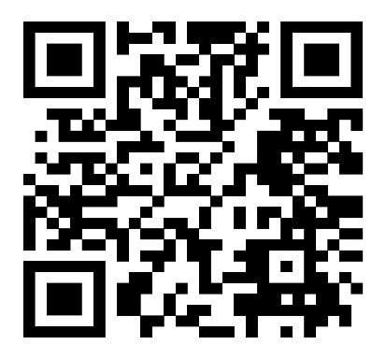
10.2 INTRODUCTION TO PYTHON PROGRAMMING
Python is a powerful multi-purpose programming language created by Guido van Rossum. It has simple easy-to-use syntax, making it the perfect language for someone trying to learn computer programming for the first time. This is a comprehensive guide on how to get started in Python, why you should learn it and how you can learn it. However, if you know other programming languages and want to quickly get started with Python. Python is a general-purpose language. It has a wide range of applications from Web development, scientific and mathematical computing to desktop graphical user Interfaces. The syntax of the language is clean and the length of the code is relatively short. It is fun to work in Python because it allows you to think about the problem rather than focusing on the syntax.
Python was selected as the primary programming language for this project due to several compelling reasons. Firstly, Python's extensive standard library and third-party packages provide a rich set of tools for various tasks, ranging from web development to data analysis and machine learning. Additionally, its dynamic typing and high-level abstractions enable rapid prototyping and development, essential for meeting project deadlines and iterating on solutions. Furthermore, Python's community driven development model ensures continuous improvement and innovation, with a vast array of resources available for learning and troubleshooting. Whether it's through online forums, tutorials, or official documentation, Python's supportive ecosystem empowers developers to overcome challenges and unlock new possibilities.
Features of Python Programming:
Python is renowned for its simplicity, readability, and versatility, making it a popular choice for a wide range of applications. Below are some of the key features that contribute to Python's appeal and effectiveness as a programming language.
1. Clear and Readable Syntax: Python's syntax is designed to be clear, concise, and easily understandable. This readability not only facilitates easier code maintenance but also enhances collaboration among developers.
2. Interpreted and Interactive: Python is an interpreted language, meaning that code execution occurs line by line, which enables rapid prototyping and debugging. Additionally, Python supports interactive mode, allowing users to execute code interactively and explore features dynamically.

3. Dynamic Typing: Python is dynamically typed, meaning that variable types are inferred at runtime. This flexibility eliminates the need for explicit type declarations, simplifying code writing and promoting code reusability.
4. High-level Abstractions: Python offers high-level abstractions such as list comprehensions, lambda functions, and object-oriented programming constructs. These features enable developers to express complex ideas in a concise and expressive manner.
5. Extensive Standard Library: Python comes with a comprehensive standard library that provides ready-to-use modules and functions for various tasks, ranging from file I/O and networking to data manipulation and web development. This rich library ecosystem accelerates development and minimizes the need for external dependencies.
6. Third-party Libraries and Frameworks: In addition to its standard library, Python boasts a vast ecosystem of third-party libraries and frameworks catering to specialized domains such as data science, web development, machine learning, and more. Popular libraries like NumPy, pandas, TensorFlow, Torch, Flask etc., extend Python's capabilities and empower developers to tackle diverse challenges.
7. Cross-platform Compatibility: Python is platform-independent, meaning that Python code can run seamlessly on different operating systems, including Windows, macOS, and Linux. This portability makes Python an ideal choice for developing cross-platform applications.
8. Community Support and Documentation: Python has a large and active community of developers who contribute to its ongoing development and maintenance. This community support is reflected in extensive documentation, online forums, and tutorials, providing valuable resources for learning and troubleshooting.
9. Ease of Integration: Python seamlessly integrates with other programming languages and technologies, allowing developers to leverage existing code and infrastructure. Whether interfacing with C/C++, Java, or .NET, Python offers robust support for interoperability and integration.
10. Scalability and Performance: While Python is often praised for its ease of use and productivity, it also offers scalability and performance when optimized correctly. Techniques such as code profiling, concurrency, and leveraging compiled extensions can significantly enhance Python's performance in resource-intensive applications.
Basic Syntax and Features: Python's syntax is designed to be clear, concise, and easy to understand, promoting readability and maintainability of code. Let's explore some of Python's fundamental concepts:
a) Variables and Data Types: Variables in Python are used to store data values. Unlike some other programming languages, Python variables do not require explicit declaration of data types. Instead, the type of a variable is dynamically inferred based on the value assigned to it. This dynamic typing simplifies code writing and makes Python code more flexible and concise. Python supports various built-in data types, including integers, floating-point numbers, strings, Booleans, lists, tuples, dictionaries, and sets. These versatile data structures empower developers to represent and manipulate data in diverse ways, catering to a wide range of application requirements.
b) Control Structures: Python provides intuitive control structures for implementing conditional logic and iteration. The if statement allows developers to execute code conditionally based on the evaluation of a Boolean expression. Similarly, for and while loops facilitate repetitive execution of code blocks, enabling iteration over collections or performing tasks until a certain condition is met.
c) Functions: Functions in Python are blocks of reusable code that perform a specific task. They promote code modularity and reusability, allowing developers to encapsulate functionality into manageable units. Python functions can accept parameters, return values, and even be nested within other functions, offering flexibility and versatility in code design.
d) Data Structures: Python offers a rich assortment of built-in data structures for organizing and manipulating data efficiently. Lists, tuples, dictionaries, and sets are among the most used data structures in Python, each with its unique characteristics and usage scenarios. These data structures facilitate tasks such as storing collections of values, mapping keys to values, and performing set operations.

Python Libraries:
Python libraries are collections of modules that provide reusable code for various functionalities, reducing development time. They cover areas like data analysis (pandas, numpy), machine learning (scikit-learn, tensorflow), web development (flask, django), and more. These libraries enhance Python's capabilities, making it versatile for different applications.
The libraries that we have used in this project are:
- Flask
- Flask is a lightweight and flexible web framework for Python.
- It follows the WSGI standard and allows rapid development of web applications.
- Flask provides built-in support for routing, templates, and request handling.
- It is extensible, allowing integration with databases, authentication, and middleware.
- Suitable for small to medium-sized applications, including APIs and microservices.
- Torch (PyTorch)
- PyTorch is an open-source deep learning framework based on the Torch library.
- It offers dynamic computation graphs, making model building more intuitive.
- Supports GPU acceleration for efficient large-scale computations.
- Commonly used for computer vision, NLP, and reinforcement learning tasks.
- Provides extensive libraries like torchvision and torchtext for specialized tasks.
- TensorFlow
- TensorFlow is a powerful machine learning framework developed by Google.
- It provides tools for building, training, and deploying AI models at scale.
- Supports both static (TensorFlow 1.x) and dynamic (TensorFlow 2.x) computation graphs.
- Works efficiently on CPUs, GPUs, and TPUs for high-performance training.
- Offers Keras as a high-level API for easier deep learning model development.

- Pandas
- Pandas is a Python library for data manipulation and analysis.
- It provides data structures like DataFrames and Series for handling tabular data.
- Offers functions for data cleaning, transformation, and aggregation.
- Supports data import/export from multiple sources like CSV, Excel, and SQL databases.
- Widely used in data science, finance, and machine learning applications.
- mysql.connector
- mysql.connector is a Python library for connecting to MySQL databases.
- It allows executing SQL queries and managing database interactions.
- Supports both synchronous and asynchronous operations.
- Provides secure authentication and transaction management features.
- Useful for integrating MySQL with Python applications for data storage and retrieval.
Workbench:
The workbench we have used in this project is Visual Studio Code. VS Code is a free, open-source code editor developed by Microsoft, known for its lightweight design and powerful features.
- Languages & Extensions – It supports multiple programming languages like Python, JavaScript, C++, and more, with extensions for added functionality.
- Features – Includes IntelliSense (smart autocompletion), debugging tools, Git integration, and terminal support.
- Customization – Highly customizable with themes, keyboard shortcuts, and settings tailored to user preferences.
- Cross-Platform – Available on Windows, macOS, and Linux, making it a preferred choice for developers worldwide.

10.3 FRONT END (CLIENT SIDE):
Client-side rendering, often known as front-end development, is a new style of site rendering that is employed in contemporary apps. In, this indicates that a browser is responsible for generating the HTML output of the web application and that a server is only needed to provide the raw web application. Here, in this application we are using HTML, CSS, JavaScript, Bootstrap to create Front end of the proposed system.
1. HTML (Hypertext Markup Language):
- HTML is the standard markup language used to create and design the structure of web pages.
- It provides a set of elements and tags to define the layout, content, and functionality of a webpage.
- HTML is essential for creating the backbone of web pages, organizing content, and linking different elements together.
2. CSS (Cascading Style Sheets):
- CSS is a style sheet language used to control the presentation and appearance of web pages.
- It allows web developers to define styles, such as colors, fonts, layouts, and animations, to enhance the visual appeal and user experience.
- CSS works by targeting HTML elements and applying styles to modify their appearance across different devices and screen sizes.
3. Bootstrap:
- It is a popular CSS framework for designing responsive and mobile-first websites.
- It provides pre-designed UI components (buttons, cards, modals, etc.), grid system for flexible layouts, built-in responsiveness (adjusts to different screen sizes).
4. JavaScript (JS):
- JavaScript is a versatile programming language commonly used for adding interactivity and dynamic behavior to web pages.
- It enables developers to create interactive features like form validation, event handling, animations.
- JavaScript runs on the client-side, making it capable of responding to user actions in real-time without the need to reload the entire webpage.
10.4 BACK END (SERVER SIDE):
Building websites and web apps has always been done using server-side rendering, also called as back-end web development. When we access a page, we send a request for data to the server, which processes it and sends back a response to the browser. All the activities required to build an HTML page that the web browser can understand are carried out on the remote server that houses the website or web application when a website renders server-side. This entails processing any required logic as well as information queries from databases for that web application. While it waits for the distant server to finish processing the request and provide the response, the web browser on the other end sits idle. When a response is sent, web browsers interpret it and show the material on the screen. Here in this application, we are using XaMPP Server.
XaMPP Server:
XAMPP is a free, open-source, cross-platform web server solution that allows developers to create and test web applications on a local machine. It is a lightweight and easy-to-use package that includes all the necessary software for running a web server.
Components of XaMPP:
XAMPP stands for:
- X → Cross-platform (works on Windows, Linux, and macOS)
- A → Apache (Web Server)
- M → MySQL/MariaDB (Database Management System)
- P → PHP (Server-side scripting language)
- P → Perl (Another programming language)
Features of XaMPP:
- Easy Installation: Pre-configured package that requires minimal setup.
- Cross-Platform Support: Available for Windows, Linux, and macOS.
- Local Server Testing: Helps developers test websites and applications before deploying online.
- Built-in Control Panel: Provides an easy way to start/stop services like Apache and MySQL.
- Supports Multiple Modules: Includes additional features like phpMyAdmin (database management tool), FileZilla FTP Server, Tomcat, and OpenSSL for security.

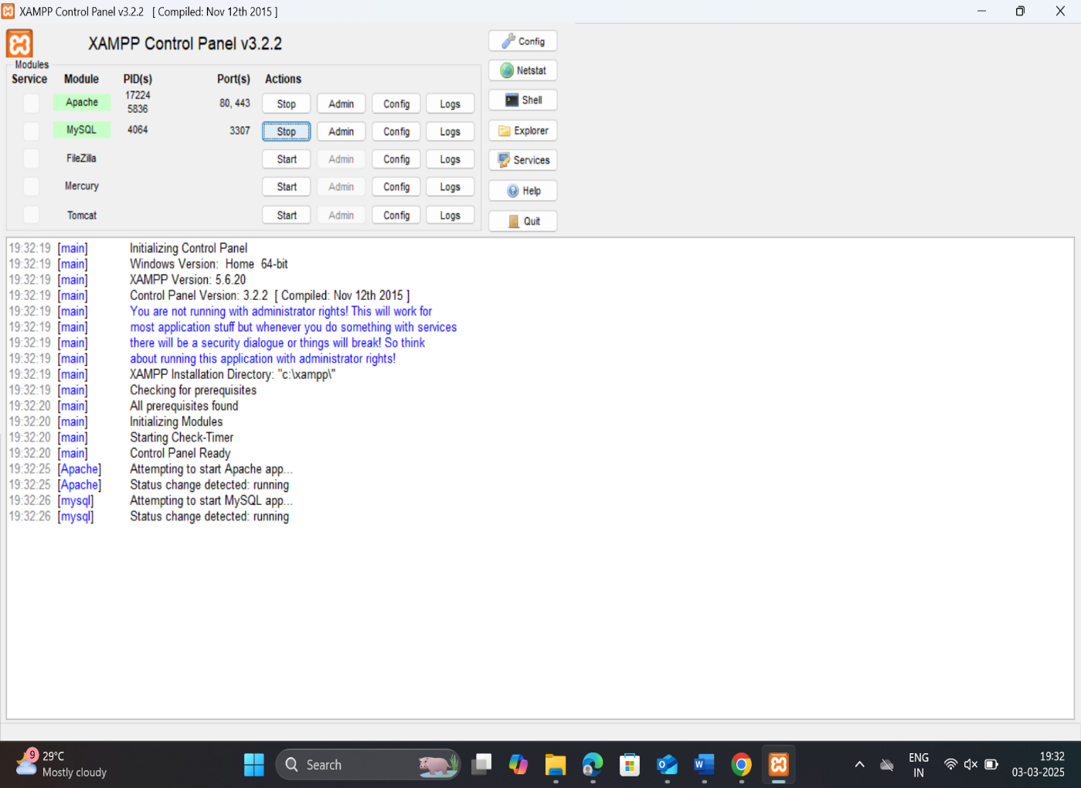
Figure – 10.4.1
The above figure (Figure – 10.2.1) displays XaMPP Server Control Panel where there are many services like Apache, Tomcat, MySQL.
Working of XaMPP:
When we install and start XAMPP:
- Apache runs as the web server, handling HTTP requests.
- MySQL/MariaDB stores and manages databases for applications.
- PHP & Perl execute server-side scripts to generate dynamic content.
- phpMyAdmin allows you to manage databases through a web interface.
Usecases of XaMPP:
- Developing and testing PHP-based applications (e.g., WordPress, Joomla).
- Running a local web server for development purposes.
- Managing MySQL databases using phpMyAdmin.
- Testing web applications before deploying them online.
Advantages of XaMPP:
- Easy to set up and use.
- Supports multiple platforms.
- Provides a local development environment.
- Comes with built-in tools like phpMyAdmin.
Disadvantages of XaMPP:
- Not recommended for production due to security risks.
- Uses default configurations, which may be insecure if exposed to the internet.
- Limited performance tuning compared to dedicated production environments.
Database:
In our application, the database that we used to store the credentials like name, email id, password (given during registration) is MySQL.
MySQL is an open-source relational database management system (RDBMS) that stores and manages data using tables. It is widely used for web applications, enterprise systems, and data-driven projects.
Key Features of MySQL:
- Relational Database: Uses tables with rows and columns to store structured data.
- SQL-Based: Uses Structured Query Language (SQL) for managing and querying data.
- High Performance: Optimized for speed and efficiency in handling large datasets.
- Scalability: Supports small to enterprise-level applications.
- Security: Provides authentication, encryption, and access control features.
- Cross-Platform Support: Works on Windows, Linux, and macOS.
- Replication & Backup: Supports database replication and backups for data protection.

10.5 INTRODUCTION TO DEEP LEARNING:
The project that we have worked on is a Deep Learning Project. Deep Learning is transforming the way machines understand, learn, and interact with complex data. Deep learning mimics neural networks of the human brain, it enables computers to autonomously uncover patterns and make informed decisions from vast amounts of unstructured data.
Neural network consists of layers of interconnected nodes, or neurons, that collaborate to process input data. In a fully connected deep neural network, data flows through multiple layers, where each neuron performs nonlinear transformations, allowing the model to learn intricate representations of the data.
In a deep neural network, the input layer receives data, which passes through hidden layers that transform the data using nonlinear functions. The final output layer generates the model’s prediction.
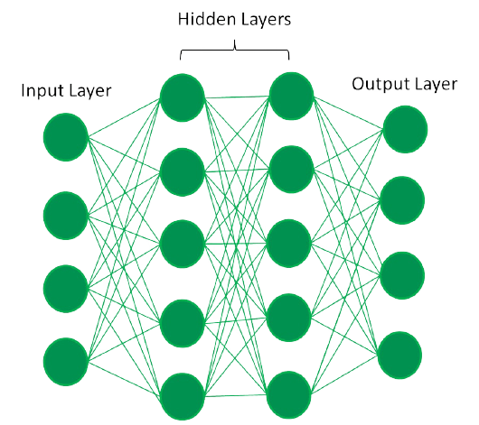
Figure-10.5.1
The above figure (Figure-10.5.1) represents a Fully Connected Deep Neural Network.
Types of Neural Networks:
1. Feedforward neural networks (FNNs)- FNNs are the simplest type of ANN, where data flows in one direction from input to output. It is used for basic tasks like classification.
2. Convolutional Neural Networks (CNNs)- CNNs are specialized for processing grid-like data, such as images. CNNs use convolutional layers to detect spatial hierarchies, making them ideal for computer vision tasks.
3. Recurrent Neural Networks (RNNs)- RNNs are able to process sequential data, such as time series and natural language. RNNs have loops to retain information over time, enabling applications like language modeling and speech recognition. Variants like LSTMs and GRUs address vanishing gradient issues.
4. Generative Adversarial Networks (GANs)- GANs consist of two networks—a generator and a discriminator—that compete to create realistic data. GANs are widely used for image generation, style transfer, and data augmentation.
5. Autoencoders- These are unsupervised networks that learn efficient data encodings. They compress input data into a latent representation and reconstruct it, useful for dimensionality reduction and anomaly detection.
6. Transformer Networks- Transformer Networks has revolutionized NLP with self-attention mechanisms. Transformers excel at tasks like translation, text generation, and sentiment analysis, powering models like GPT and BERT.
Amongst various types of neural networks in our project we have used CNNs. We have used Faster RCNN and YOLOv9 which are types of CNN.
Convolutional Neural Networks (CNNs):
A Convolutional Neural Network (CNN) is a type of Deep Learning neural network architecture commonly used in Computer Vision. Computer vision is a field of Artificial Intelligence that enables a computer to understand and interpret the image or visual data.
When it comes to Machine Learning, Artificial Neural Networks perform really well. Neural Networks are used in various datasets like images, audio, and text. Different types of Neural Networks are used for different purposes, for example for predicting the sequence of words we use Recurrent Neural Networks more precisely an LSTM, similarly for image classification we use Convolution Neural networks.
Convolutional Neural Network (CNN) is the extended version of artificial neural networks (ANN) which is predominantly used to extract the feature from the grid-like matrix dataset. For example, visual datasets like images or videos where data patterns play an extensive role.
A Convolutional Neural Network (CNN) is a deep learning algorithm specifically designed for processing and analyzing visual data, such as images and videos. CNNs are highly effective in tasks like image classification, object detection, facial recognition, and more. They are inspired by the human visual system and are particularly well suited for handling structured grid-like data, like pixels in an image.
CNN Architecture:
Convolutional Neural Network consists of multiple layers like the input layer, Convolutional layer, Pooling layer, and fully connected layers. The Convolutional layer applies filters to the input image to extract features, the Pooling layer down samples the image to reduce computation, and the fully connected layer makes the final prediction. The network learns the optimal filters through backpropagation and gradient descent.
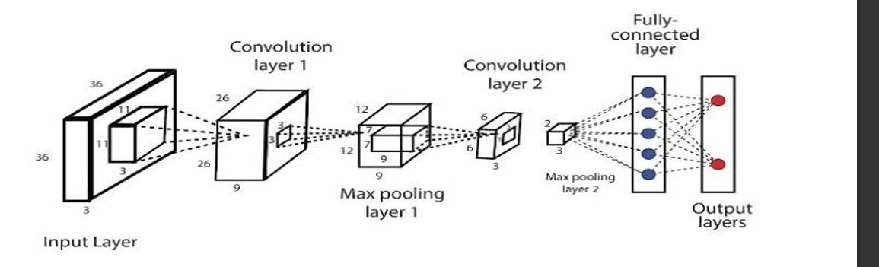
Figure- 10.5.2
The above figure (Figure- 10.5.2) represents CNN architecture. CNNs consist of multiple layers that work together to automatically learn and extract features from the input data. The key components of a CNN include:
- Convolutional Layers: These layers are responsible for extracting important patterns and features from the input data. They use convolutional filters (also known as kernels) to perform operations on small regions of the input, sliding these filters across the entire image to detect various features like edges, textures, or more complex structures.
- Activation Functions: After each convolutional operation, an activation function is applied element-wise to introduce non-linearity into the model. Common activation functions used in CNNs include the Rectified Linear Unit (ReLU), which helps capture complex relationships in the data.
- Pooling Layers: Pooling layers (e.g., Max-Pooling or Average-Pooling) reduce the spatial dimensions of the data. They help make the network computationally efficient and reduce overfitting by selecting the most important information from each region.
- Fully Connected Layers: These layers connect every neuron in one layer to every neuron in the next layer, similar to traditional neural networks. They combine the features learned by previous layers to make predictions.
- Output Layer: The final layer produces the network's predictions. In classification tasks, this layer often uses a SoftMax activation function to obtain class probabilities, allowing the model to decide about which class an input belongs to.
CNNs are trained through a process called backpropagation, where the network learns to adjust its internal parameters (weights and biases) based on the difference between its predictions and the ground truth labels. This training process involves minimizing a loss function, and it continues until the model achieves satisfactory performance on a given task. The depth and complexity of a CNN can vary depending on the problem and the dataset.
CNNs have revolutionized computer vision tasks and are widely used in various applications, from autonomous driving to medical image analysis. Their ability to automatically learn hierarchical features from raw data makes them a powerful tool for visual data analysis.
In the Convolutional layer, filters are applied to the input image to extract essential features. The subsequent Pooling layer down samples the image, reducing computational complexity. Finally, the fully connected layer makes the ultimate prediction. Within the Convolutional layer, we implement techniques such as padding, stride, and ReLu functions. In the Max Pooling layer, various pooling methods like max pooling, average pooling, sum pooling, and global max pooling are employed to diminish image size This reduction in size not only optimizes computational efficiency but also eliminates extraneous data, thereby enhancing prediction accuracy.
Transfer Learning:
Transfer learning is a powerful technique in Convolutional Neural Networks (CNNs) where a pretrained model, developed for a task, is reused as the starting point for a new model on a related task. Instead of training a CNN from scratch, transfer learning leverages the knowledge gained from solving one problem and applies it to a different but related problem.
Here's how transfer learning typically works in CNNs:
1. Pre-trained Model Selection: Choose a pre-trained CNN model that has been trained on a large dataset, such as ImageNet. Models like VGG, ResNet, Inception, and MobileNet are commonly used due to their effectiveness and availability.
2. Feature Extraction: Remove the final classification layers of the pre-trained model, leaving the convolutional base intact. This base consists of layers that learn to extract hierarchical features from input images. These features are general and transferable across different tasks.
3. Fine-tuning: Add new classification layers (often a fully connected layer followed by a SoftMax layer) on top of the convolutional base. These new layers are then trained using a smaller dataset specific to the new task. During training, the weights of the convolutional base layers may be finetuned along with the new classification layers.
Transfer learning offers several advantages:
1. Reduced Training Time: Since the pre-trained model has already learned generic features from a large dataset, training on a new dataset requires less time and computational resources.
2. Better Performance: Transfer learning often leads to better generalization and performance, especially when the new dataset is small or similar to the original dataset used for pre-training.
3. Effective Feature Representation: The convolutional base of the pre-trained model serves as an effective feature extractor, capturing hierarchical representations of the input data.
In the proposed system, Transfer Learning with pretrained Convolutional Neural Network (CNN) models offers significant advantages by simplifying feature extraction from a source task like ImageNet. This allows the model to leverage learned representations for the target task, leading to a notable reduction in training time. This efficient approach skips intensive initial training, saving both time and computational resources. Notable pretrained models used in our proposed system encompass MobileNet.

MobileNet:
MobileNet is a pre-trained model designed for efficient deep learning tasks, particularly in mobile and embedded devices. It is a family of lightweight convolutional neural networks (CNNs) optimized for speed and low-power applications.
Key Features of MobileNet:
- Pre-trained on ImageNet – MobileNet models are pre-trained on large datasets like ImageNet, making them useful for transfer learning.
- Depthwise Separable Convolutions – Uses a special type of convolution to reduce computational cost while maintaining accuracy.
- Lightweight & Fast – Designed for real-time applications on mobile and edge devices.
- Variants – Includes MobileNetV1, MobileNetV2, and MobileNetV3, with improvements in efficiency and accuracy.
- Transfer Learning – Commonly used in TensorFlow and PyTorch for tasks like image classification, object detection, and segmentation.
Advantages of CNNs:
- Good at detecting patterns and features in images, videos, and audio signals.
- Robust to translation, rotation, and scaling invariance.
- End-to-end training, no need for manual feature extraction.
- Can handle large amounts of data and achieve high accuracy.
Disadvantages of CNNs:
- Computationally expensive to train and require a lot of memory.
- Can be prone to overfitting if not enough data or proper regularization is used.
- Requires large amounts of labelled data.
- Interpretability is limited, it’s hard to understand what the network has learned.
Deep Learning Applications:
1. Computer vision
2. Natural language processing (NLP)
3. Gaming
4. Robotics

Advantages of Deep Learning
- High accuracy: Deep Learning algorithms can achieve state-of-the-art performance in various tasks, such as image recognition and natural language processing.
- Automated feature engineering: Deep Learning algorithms can automatically discover and learn relevant features from data without the need for manual feature engineering.
- Scalability: Deep Learning models can scale to handle large and complex datasets, and can learn from massive amounts of data.
- Flexibility: Deep Learning models can be applied to a wide range of tasks and can handle various types of data, such as images, text, and speech.
- Continual improvement: Deep Learning models can continually improve their performance as more data becomes available.
Disadvantages of Deep Learning
- High computational requirements: Deep Learning AI models require large amounts of data and computational resources to train and optimize.
- Requires large amounts of labelled data: Deep Learning models often require a large amount of labelled data for training, which can be expensive and time- consuming to acquire.
- Interpretability: Deep Learning models can be challenging to interpret, making it difficult to understand how they make decisions.
- Overfitting: Deep Learning models can sometimes overfit to the training data, resulting in poor performance on new and unseen data.
- Black-box nature: Deep Learning models are often treated as black boxes, making it difficult to understand how they work and how they arrived at their predictions.

